**DIRECT POWER CONTROL OF DFIG UNDER**

**DISTORTED GRID VOLTAGE**

# A Major Project Report Submitted in partial fulfillment of the requirements for the award of the Degree of

**BACHELOR OF TECHNOLOGY**

**in**

**ELECTRICAL AND ELECTRONICS ENGINEERING**

***by***

|  |  |
| --- | --- |
|  |  |
| **AMARENDER REDDY PATEL** | **(12881A0235)** |
| **K. MADHAV** | **(12881A0236)** |
| **D. MANINDHAR REDDY** | **(12881A0237)** |
| **P. MEGHASYAM REDDY** | **(12881A0239)** |
|  |  |

**Under the guidance of**

**Mr. K. KALYAN KUMAR M.TECH, (PH.D)** **Assistant Professor**



Department of **E**lectrical & **E**lectronics **E**ngineering

**VARDHAMAN COLLEGE OF ENGINEERING**

**(Autonomous)**

**Shamshabad, Hyderabad – 501 218**

**Affiliated to JNTU, HYDERABAD. 2015-16**

**VARDHAMAN COLLEGE OF ENGINEERING**

**(Autonomous)**

**Shamshabad, Hyderabad-501 218**

# Department of **E**lectrical and **E**lectronics **E**ngineering



**CERTIFICATE**

Certified that this is a bonafide record of the dissertation work entitled, “**DIRECT**

**POWER CONTROL OF DFIG UNDER DISTORTED GRID VOLTAGE ”,**done by **AMARENDER REDDY PATEL (12881A0235), K.MADHAV(12881A0236), D. MANINDHAR REDDY(12881A0237), P.MEGHASHYAM REDDY (12881A0239)** submitted to the faculty of Electrical & Electronics Engineering,in partial fulfillment of the requirement for the Degree of **BACHELOR OF** **TECHNOLOGY** in **Electrical and Electronics Engineering** from Jawaharlal NehruTechnological University Hyderabad during the year 2015-16.

Sig nature of the Supervisor Signature of Head of the Department

Mr. K.KALYAN KUMAR M.TECH. Mr.MD.ASIF M.TECH

**Assistant Professor** **Associate Professor**

## AKNOWLEDGEMENT

The satisfaction and euphoria that accompany the successful completion of any task would be incomplete without the mentioning of the people whose constant guidance and encouragement made it possible. We take pleasure in presenting before you, our project which is result of studied blend of both research and knowledge.

We express our earnest gratitude to our internal guide, **Mr. K. KALYAN KUMAR,** for his constant support, encouragement and guidance. We are grateful for his cooperation and valuable suggestions.

We would like to express our deep sense of gratitude to **Mr. MD. ASIF** Head of the Department for his guidance, intense support and encouragement, which helped us in completing the topic on time.

Finally, we express my gratitude to all other members who are involved either directly or indirectly for the completion of this topic.

**AMARENDER REDDY PATEL (12881A0235)**

**K. MADHAV (12881A0236)**

**D. MANINDHAR REDDY (12881A0237)**

**P. MEGHASHYAM REDDY (12881A0239)**

## ABSTRACT

This project describes a direct power control (DPC) strategy for a doubly fed induction generator (DFIG)-based wind power generation system under distorted grid voltage. By analyzing the six times grid frequency power pulsation produced by the fifth and seventh grid voltage harmonic components, a novel DPC strategy with vector proportional integrated (VPI) regulator has been proposed to implement the smooth active and reactive power output of DFIG. The performance analysis of the proposed DPC strategy, including the steady and dynamic state performance, closed-loop operation stability, and rejection capability for the grid voltage distorted component and back EMF compensation item has been investigated. The availability of the proposed DPC strategy with a VPI regulator is verified by MATLAB/SIMULINK results of DFIG system under harmonically distorted grid condition.

## CONTENTS

**Title i**

**Certificate ii**

**Acknowledgement iii**

**Abstract iv**

**Contents of report v**

**List of figures vii**

1. **Introduction 1** 
   1. Doubly-fed Induction Generator (DFIG) Models 2
   2. Flicker 3
   3. Influence factor 4
2. **Literature Survey 6**
3. **Double fed induction generator (dfig) 8** 
   1. Principle of a double fed induction generator connected to a wind turbine 8
   2. System model 10
   3. Dfig control 12
   4. Types of double fed induction generator 13
      1. Brushless doubly-fed induction electric generator 13
      2. Brushless wound-rotor doubly-fed electric generator 14
      3. Wound-rotor doubly-fed electric generator construction 14
   5. Electronic control 15
   6. Efficiency 15
4. **Harmonics 17** 
   1. Why Worry About Them 19
   2. Where They Come From 21
   3. When are they a problem 26
   4. How do you get rid of them 28

1. **Mathematical model of dfig under harmonically distorted voltage 29** 
   1. Performance analysis of the DPC strategy with a VPI regulator 35
   2. Steady-state Performance 38
   3. Dynamic Performance Analysis 39
   4. Rejection of Grid Voltage Distortion on the Stator Active and Reactive Power 42
   5. Influence of Back EMF on the Steady-State Stator Active and Reactive Power 46
2. **MATLAB 48** 
   1. The MATLAB system consists of five main parts 49
   2. Simulink 49
   3. Concept of signal and logic flow 50
      1. Connecting blocks 50
      2. Sources and sinks 51
      3. Continuous and discrete systems 53
      4. Non-linear operators 53
   4. Mathematical operations 53
      1. Signals & Data Transfer 54
      2. Making subsystems 54
      3. Setting simulation parameters 55
      4. Matlab model 56
3. **Conclusion 67**

**8.References 68**

## LIST OF FIGURES

|  |  |  |
| --- | --- | --- |
| Fig 1.1 Relationship between the (dq)+,(dq)5- and (dq)7+ reference frames. | | 2 |
| Fig.1.2 T-representation of the DFIG equivalent circuit in the positive synchronous (dq)+ reference frame rotating at the speed of w1. |  | 2 |
| Fig 1.3 Cross Sectional View of Wound Rotor Induction Machine |  | 3 |
| Fig.3.1 Doubly-fed Induction Generator |  | 8 |
| Fig.3.2 Principle of DFIG connected to a wind turbine. |  | 9 |
| Fig 3.3 Complex vector dynamic representation. |  | 11 |
| Fig 3.4 First step |  | 12 |
| Fig 3.5 Second step |  | 12 |
| Fig.4.1 Sine wave |  | 17 |
| Figure.4.2 Fundamental with two harmonics |  | 18 |
| Figure.4.3 Additive Third Harmonics |  | 19 |
| Fig. 4.4 Current Waveform |  | 22 |
| Fig. 4.5 Harmonic Spectrum of Current Waveform Shown in Figure 4.4 |  | 22 |
| Fig. 4.6 Power Quality Monitor with Harmonic Analysis |  | 25 |
| Fig. 5.1 DPC scheme of the DFIG under the distorted grid voltage using the VPI regulator. |  | 33 |
| Fig.5.2 Bode diagram of the VPI regulator |  | 37 |
| Fig. 5.3 Bode diagram of *GP s* (*s*) and *GQ s* (*s*) with different parameters | | 39 |
| Fig. 5.4 Bode diagram of the closed-loop control transfer function under VOC and DPC strategy Fig. 5.5 Bode diagram of *GP s Usd* (*s*) with different parameters | | 41 |
| Fig. 5.6 Bode diagram of *D*(*s*) with different parameters | | 43 |
| Fig. 5.7 Bode diagram of *GP s E rd* (*s*) with different parameters | | 45 |
| Fig 6.1 Simulink library browser | | 50 |
| fig 6.2 Connecting blocks | | 51 |

|  |  |  |
| --- | --- | --- |
| fig 6.3 Sources and sinks |  | 52 |
| fig 6.4 continous and descrete systems |  | 53 |
| fig 6.5 simulink blocks |  | 54 |
| fig 6.6 Simulink math blocks |  | 55 |
| fig 6.7 signals and systems |  | 56 |
| fig.6.8 Sample parameters values |  | 57 |
| Fig. 7.1 Block diagram of experiment system. |  | 58 |
| Fig.7.2 Proposed DPC scheme of DFIG under distorted grid voltage using the VPI regulator |  | 59 |
| Fig. 7.3. Experimental result of the DFIG system performance under the ideal grid voltage condition. |  | 61 |
| Fig. 7.4. Experimental result of the DFIG system performance under the distorted grid voltage condition with VPI disabled. |  | 62 |
| Fig.7.5 Experimental result of the DFIG system steady performance under the distorted grid voltage condition with VPI enabled. |  | 63 |
| Fig.7.6 Experimental result of the DFIG system transient performance under the distorted grid voltage condition with VPI enabled. |  | 64 |
| Fig.7.7 Experimental result of the DFIG stator active power reference stepping transient performance under the distorted grid voltage condition with VPI enabled. |  | 65 |
| Fig.7.8 Experimental result of the DFIG system operating from |  | 66 |
| sub-synchronous to super-synchronous state under the distorted grid voltage condition with VPI enabled.  **TABELS** | |
| Table.4.1 Harmonic Sequencing Values in Balanced Systems | | 20 |
| Table 4.2. Sample of Harmonic Values for Fluorescent lighting | | 23 |
| Table 4.4 Typical Harmonics Found for Different Converters. | | 26 |
| Table 4.5 Current Harmonic Limits as per IEEE 519-1992 | | 27 |
| Table 4.6 Voltage Harmonic Limits as per IEEE 519-1992 | | 27 |
| Table 7.1 Parameters of experimental setup | | 59 |
| Table 7.2 Harmonic analysis data with the proposed dpc strategy | | 63 |

## 1.INTRODUCTION

Under harmonically distorted grid conditions, the DFIG would contain six times grid frequency pulsation item and an average item of stator active and reactive power. Therefore, PI regulator would not be appropriate due to the insufficient gain at the six times grid frequency. PIR regulator could achieve zero steady-state error, in which the PI and resonant part is used to deal with the average item and the pulsation item respectively. However, unexpected peak of magnitude response at the frequency larger than resonant 300 Hz may arise due to the pole distribution of control object DFIG, which is detrimental to the stable closed-loop operation. Considering that it needs one specific resonant controller to deal with one specific harmonic sequence in the PR regulator, the control loop structure complexity would increase as the number of harmonic sequence increases, which is harmful to the stable closed-loop operation. The VPI regulator, based on pole-zero cancellation to avoid the unexpected gain peak can be used to remove the DFIG stator active and reactive power pulsation components due to the adequate closed-loop phase margin and accurate ac signal tracking capability.

This project investigates the DPC strategy of wind-turbine driven DFIG generation systems under distorted grid voltage conditions. First, the mathematical model of a DFIG system under fifth- and seventh-order harmonically distorted grid supply is briefly mentioned as a foundation. Considering that the wind power generation should focus on the energy quality injected into the grid, the stator active and reactive power without any oscillation is selected as the harmonic control target. Then, focused on the steady-state tracking accuracy, dynamic performance analysis, closed-loop operation stability, as well as the rejection capability of the grid voltage distorted component and back EMF compensation item, the performance analysis of the proposed DPC control strategy with VPI regulator is conducted.

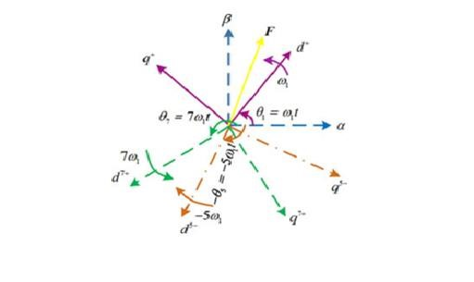

Fig 1.1 Relationship between the (dq)+,(dq)5- and (dq)7+ reference frames.

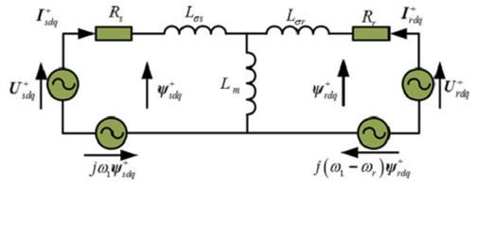

Fig.1.2 T-representation of the DFIG equivalent circuit in the positive synchronous (dq)+ reference frame rotating at the speed of w1.

Finally, the experimental system on 1 kW laboratory DFIG has been built to validate the availability of the proposed DPC strategy using the VPI regulator.

**1.1 Doubly-fed Induction Generator (DFIG) Models**

For the purposes of better understanding and designing vector control schemes in a wind turbine-generator system, it is necessary to know the dynamic model of the machine subjected to control. A model of the electrical machine which is adequate for designing the control system must preferably incorporate all the important dynamic effects occurring during steady state and transient operations. It should be valid for any arbitrary time variations of the voltages and currents generated by the converter which supplies the machine. In this section, such a model which is valid for any instantaneous variations of the voltages and currents, and can adequately describe the performance of the machine under both steady state and transient operations, will be developed in both the ABC reference frame and several different DQO reference frames.

**DFIG Model Expressed in the ABC Reference Frame**

For simplicity, a wound rotor induction machine is considered with symmetrical two poles and three-phase windings. Figure 2.4 shows the cross-sectional view of the machine under consideration, where the effects of slotting have been neglected.

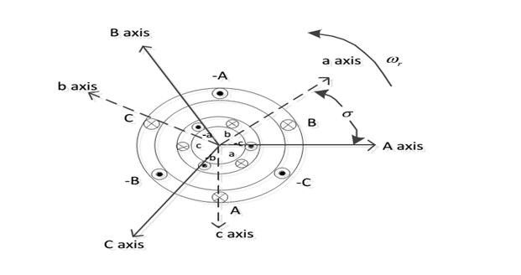

Fig 1.3 Cross Sectional View of Wound Rotor Induction Machine

**1.2 Flicker**

The reason of flickerGrid-connected wind turbines may have considerable fluctuations in the output power, as the wind is a weather-dependent power source. Reference [10] indicates that the grid suffers voltage fluctuations and flicker as the wind turbines‟ output power, which flows into the grid varies. The flicker produced by gridconnected wind turbines during continuous operation is mainly caused by fluctuations in the output power due to wind speed variations, the wind gradient and the tower shadow effect. As a consequence of the combination of windspeed variations, the wind gradient and the tower shadow effect, an output power drop will appear three times per revolution for a three-bladed wind turbine. This frequency is normallyreferred to as p 3 . For fixed speed wind turbines with induction generators, power pulsations up to 20% of the average power at the frequency of p3 will be generated. The tower shadow effect is produced because the wind turbine tower offers resistance to the wind flow, and it disturbs the wind flow both upstream and downstream. Far from the tower influence, the wind speed is unchanged, while it increases when approaching the tower and decreases when coming closer. A Fourier series with harmonic multiples of p3 frequency can represent this shadow effect. The tower shadow effect is more important to the wind turbines having their blades downwind of the tower. The wind shear phenomenon also produces torque oscillations caused by the wind speed gradient along the height of the area swept by the blades. The wind speed gradient may be described in polar coordinates centered at the hub elevation by the binomial series. As the rotor samples the incoming wind, it sees the wind profiles as a periodical varying function of the time with harmonic multiples of p 3 frequency.

The output power of grid-connected wind turbines have been analyzed in the frequencydomain. The results show that, in addition to the dominating periodic component p3, the p6, p9, p12 and p18 components are visible too. A possible reason for the existence of the p1 component is that the rotor may be unbalanced. Another possibility is that one of the blades produces a higher torque than the other ones. The tower resonance frequency is also detectable which is assumed originating from a sideways oscillation of the turbine.

**1.3 Influence factors**

There are numerous of factors that affect flicker emission of grid-connected wind turbines during continuous operation, such as wind characteristics (e.g. mean wind speed, turbulence intensity), grid conditions (e.g. short circuit capacity, grid impedance angle) and types of wind turbines (e.g. fixed speed, variable speed). The flicker level increases at higher wind speeds due to higher turbulence in the wind. For fixed speed wind turbines, the flicker level increases around three times from lower to higher wind speeds.

For variable speed wind turbines, the flicker level increases with a rise in the wind speed, until the wind speed reaches its rated value. As the wind turbine reaches its rated power, the variable speed system will smooth out the power fluctuations and, thereby, limit the flicker. The turbulence intensity has a significant influence on flicker emission of grid-connected wind turbines. The flicker level has an almost directly proportional relation with the turbulence intensity. The flicker level is approximately inversely proportional to the short circuit capacity at the PCC of wind turbines. The grid impedance angle is so important that, if a proper value is chosen, the voltage changes from the varying active power flow will be cancelled by that from the varying reactive power flow and, therefore, the voltage fluctuations and the flicker level are reduced. The determining factor is the difference between the grid impedance angle and the wind turbine power factor angle.

When the difference approaches 90 degrees, the flicker emission is minimized. Different types of wind turbines produce different flicker levels. The flicker level produced by variable speed wind turbines is considerably lower than that produced by fixed speed wind turbines. A 4 time reduction of the flicker level can be realized through variable speed operation. The flicker contribution from the p3 component is quite significant for fixed speed wind turbines. However, variable speed wind turbines have the ability to reduce the p3 pulsations in the output power. Most of the references listed above are focused on flicker emission of fixed speed wind turbines. However, no specific works have been concentrated on flicker emission of variable speed wind turbines with DFIG and the corresponding effects of the above mentioned influence factors.

## 2.Literature Survey

WIND power generation based on the doubly-fed induction generator (DFIG) has gained increasing popularity due to several advantages, including smaller converters rating around 30% of the generator rating, variable speed and four quadrant active and reactive power operation capabilities, lower converter cost, and power losses compared with the fixed-speed induction generators or synchronous generators with full-sized converters [1], [2]. Several novel control strategies have been investigated in order to improve the DFIG operation performance, i.e., the vector oriented control (VOC) [3], direct power control [4], and predictive current control [5].

Up to now, the steady and transient response of DFIG-based wind power generation system under balanced [6] and unbalanced [7]–[11] grid voltage conditions have been discussed widely. There are mainly two control methods adopted, VOC, and direct power control (DPC). The authors in [7]–[9] introduced the unbalanced control strategy with the VOC technique, in which the detrimental influence on the DFIG system caused by negative component of the grid voltage was also analyzed. Several alternative control targets focusing on the elimination of negative component of stator/rotor current, as well as stator active/reactive power and electromagnetic torque pulsation were proposed. Zhouet al. [10], [11] explicitly illustrated the unbalanced control strategy using the DPC technique with different stator power compensation item, in which the five different control targets were proposed to improve the DFIG operation ability under transient unbalanced grid voltage.

However, there are always voltage harmonic distorted components in the transmission system of the power grid. It has been pointed out that the highly distorted stator/rotor current, significant electromagnetic torque and power oscillations would occur if grid voltage harmonics are not taken into account by DFIG‟s control strategy [12]. The authors in [13]–[16] have presented a theoretical analysis and an improved VOC strategy for DFIG, in which alternative control targets were proposed to keep the three-phase sinusoidal stator/rotor current, or remove pulsations in both stator active and reactive powers, or remove pulsations in the electromagnetic torque and stator reactive power. Furthermore, in addition to the conventional rotor current control loop, a distinctive and independent stator current resonant control loop was also given out in [17] to successfully eliminate the stator current harmonic components.

Nevertheless, all the aforementioned investigation on the DFIG system under the harmonic voltage is based on the VOC technique, which requires the decomposition of grid voltage fundamental and harmonic components; thus, the closed-loop operation stability and dynamic response of the entire control system will be deteriorated [10], [11]. The DPC technique has been proved to be preponderant for DFIG control, such as simple implementation, fast dynamic response, robustness against parameter variations, and grid disturbance [18], [19]. In order to overcome the traditional DPC drawback of variable switching frequency, the DPC integrated with space vector modulation (DPC-SVM) has been adopted to decrease the broadband harmonics injecting into the grid and simplify the filter design [20].

For the purpose of achieving excellent DFIG system performance with DPC strategy under harmonically distorted grid conditions, it is important to implement the accurate control of stator active and reactive power. Several regulators are capable of accurately tracking the actual signal according to the reference one, i.e., hysteresis regulator [3], proportional-resonant (PR) [21]–[25] regulator in stationary frame; traditional PI regulator [21], [22], proportional integral resonant (PIR) regulator [13]–[15], [21], [22],

[26], vector PI (VPI) regulator [21], [22] in the synchronous frame.

### 3. DOUBLE FED INDUCTION GENERATOR (DFIG)

DFIG is an abbreviation for Double Fed Induction Generator, a generating principle widely used in [wind turbines.](http://en.wikipedia.org/wiki/Wind_turbine) It is based on an [induction generator](http://en.wikipedia.org/wiki/Induction_generator) with a multiphase wound rotor and a multiphase slip ring assembly with brushes for access to the rotor windings. It is possible to avoid the multiphase slip ring assembly (see [brushless doubly-fed electric machines)](http://en.wikipedia.org/wiki/Doubly-fed_electric_machine#Brushless_doubly-fed_induction_electric_machines), but there are problems with efficiency, cost and size. A better alternative is a [brushless wound-rotor doubly-fed electric machine.](http://en.wikipedia.org/wiki/Doubly-fed_electric_machine#Brushless_wound-rotor_doubly-fed_electric_machine)

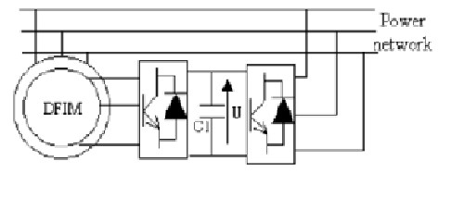

Fig.3.1 Doubly-fed Induction Generator

**3.1 Principle of A Double Fed Induction Generator Connected To A Wind Turbine**

The principle of the DFIG is that rotor windings are connected to the grid via slip rings and back-to-back [voltage](http://en.wikipedia.org/wiki/Voltage) source converter that controls both the rotor and the grid currents. Thus [rotor](http://en.wikipedia.org/wiki/Rotor_(electric)) [frequency](http://en.wikipedia.org/wiki/Frequency) can freely differ from the grid frequency (50 or 60 Hz). By using the converter to control the rotor currents, it is possible to adjust the active and reactive power fed to the grid from the stator independently of the generator's turning speed. The control principle used is either the two-axis current [vector control](http://en.wikipedia.org/wiki/Vector_control_(motor)) or [direct torque control (DTC).](http://en.wikipedia.org/wiki/Direct_Torque_Control) DTC has turned out to have better stability than current vector control especially when high reactive currents are required from the generator.

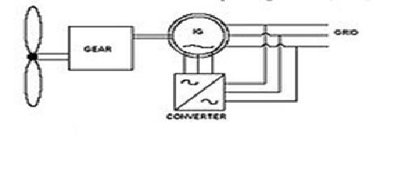

Fig.3.2 Principle of DFIG connected to a wind turbine.

The doubly-fed generator rotors are typically wound with 2 to 3 times the number of turns of the stator. This means that the rotor voltages will be higher and currents respectively lower. Thus in the typical ± 30 % operational speed range around the synchronous speed, the rated current of the converter is accordingly lower which leads to a lower cost of the converter. The drawback is that controlled operation outside the operational speed range is impossible because of the higher than rated rotor voltage. Further, the voltage transients due to the grid disturbances (three- and two-phase voltage dips, especially) will also be magnified. In order to prevent high rotor voltages - and high currents resulting from these voltages - from destroying the [IGBTs](http://en.wikipedia.org/wiki/IGBT) and [diodes](http://en.wikipedia.org/wiki/Diode) of the converter, a protection circuit (called [crowbar)](http://en.wikipedia.org/wiki/Crowbar_(circuit)) is used.

The crowbar will short-circuit the rotor windings through a small resistance when excessive currents or voltages are detected. In order to be able to continue the operation as quickly as possible an [active crowbar](http://en.wikipedia.org/wiki/Crowbar_(circuit))  has to be used. The active crowbar can remove the rotor short in a controlled way and thus the rotor side converter can be started only after 20-60 ms from the start of the grid disturbance. Thus it is possible to generate reactive current to the grid during the rest of the voltage dip and in this way help the grid to recover from the fault. A doubly fed induction machine is a wound-rotor doubly-fed electric machine and has several advantages over a conventional induction machine in wind power applications. First, as the rotor circuit is controlled by a power electronics

converter, the induction generator is able to both import and export [reactive power.](http://en.wikipedia.org/wiki/Reactive_power) This has important consequences for [power system stability](http://en.wikipedia.org/w/index.php?title=Power_system_stability&action=edit&redlink=1) and allows the machine to support the grid during severe voltage disturbances ([low voltage ride through, LVRT).](http://en.wikipedia.org/wiki/Low_voltage_ride_through) Second, the control of the rotor voltages and currents enables the induction machine to remain [synchronized](http://en.wikipedia.org/wiki/Synchronization_(alternating_current)) with the grid while the wind turbine speed varies. A variable speed wind turbine utilizes the available wind resource more efficiently than a fixed speed wind turbine, especially during light wind conditions. Third, the cost of the converter is low when compared with other variable speed solutions because only a fraction of the mechanical power, typically 25-30 %, is fed to the grid through the converter, the rest being fed to grid directly from the stator. The efficiency of the DFIG is very good for the same reason.

**3.2 SYSTEM MODEL:**

The electrical model for the system is developed using dynamic phases or complex space vectors in the anachronously rotating – reference frame. An illustration of the axes conventions. The default convention assumed here aligns the -axis with the positive real axis and the -axis with the negative imaginary axis, and the complex vector. In certain instances it is convenient to locate the real and imaginary axes aligned with a particular complex vector, for instance , in which case the axes are designated and respectively, and the real and (negative) imaginary components with respect to the reference are designated and , a respectively.

The following simplifying assumptions are made in the development of the model:

1. The iron losses, mechanical and power converter losses are negligible.
2. The magnetic circuit of the machine can be represented by a linear model.
3. The entire mechanical system can be modeled using a lumped inertia parameter referred to the electrical angle and speed of the induction generator.
4. The power converters can be modeled using state-space averaged representation to represent their low frequency dynamics.
5. The wind farm collection network to PCC is electrically stiff. The conventional DFIG T circuit is transformed into an equivalent circuit

The system equivalent circuit models under these assumptions the complete set of nonlinear state equations are

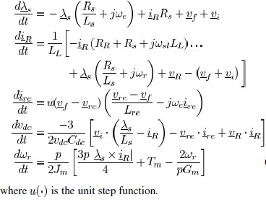

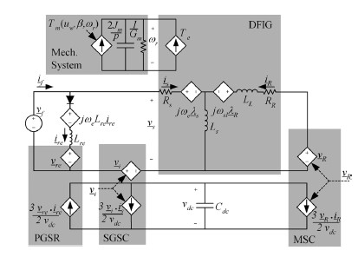

Fig 3.3 Complex vector dynamic representation.

The complex vector dynamic state equations are used form the evaluation of steady state properties and the development of control laws. The dynamic states of the system include the stator flux, , rotor current , rectifier current , dc link voltage, , and rotor speed, . Controllable inputs to the system include the complex voltage vectors for the MSC and SGSC, and respectively. Since the PGSR is a passive network, its conduction state is determined by the state of the diode which conducts when the voltage is greater than. The mechanical power generated at the wind turbine shaft is proportional to the coefficient of performance and the cube of the wind speed. The mechanical torque production due to wind energy capture can be throttled via the blade pitch actuators.

**3.3 DFIG CONTROL:**

When the DFIG is connected to a network, connection must be done in three steps which are presented below the first step is the regulation of the statoric voltages with the network voltages as reference the second step is the stator connection to this network. As the voltages of the two devices are synchronized, this connection can be done without problem. Once this connection is achieved, the third step, which constitutes the topic of this project, is the power regulation between the stator and the network.

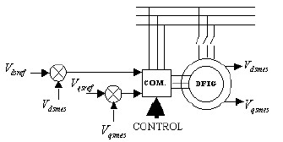

#### Fig 3.4 First step

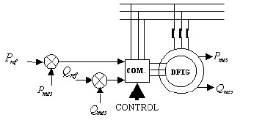

#### Fig 3.5 Second step

**3.4 TYPES OF DOUBLE FED INDUCTION GENERATOR:**

**3.4.1 Brushless doubly-fed induction electric generator**

Brushless doubly-fed induction electric generator (i.e., [electric motors](http://en.wikipedia.org/wiki/Electric_motor) or [electric generators)](http://en.wikipedia.org/wiki/Electric_generator) are constructed by adjacently placing two multiphase [winding](http://en.wikipedia.org/wiki/Winding) sets with unlike pole-pairs on the [stator](http://en.wikipedia.org/wiki/Stator) body. With unlike pole-pairs between the two winding sets, low frequency magnetic induction is assured over the speed range. One of the stator winding sets (power winding) is connected to the grid and the other winding set (control winding) is supplied from a frequency converter. The shaft speed is adjusted by varying the frequency of the control winding.

As a doubly-fed electric machine, the rating of the frequency converter need only be fraction of the machine rating. The brushless doubly-fed induction generator does not utilize core real-estate efficiently and the dual winding set stator assembly is physically larger than other electric machines of comparable power rating. In addition, a specially designed rotor assembly tries to focus most of the mutual [magnetic field](http://en.wikipedia.org/wiki/Magnetic_field) to follow an indirect path across the air-gap and through the rotor assembly for inductive coupling (i.e., brushless) between the two adjacent winding sets. As a result, the adjacent winding sets are excited independently and actively participate in the electro-mechanical energy conversion process, which is a criterion of doubly-fed electric machines.

The type of rotor assembly determines if the machine is a [reluctance](http://en.wikipedia.org/wiki/Reluctance) or [induction](http://en.wikipedia.org/wiki/Electromagnetic_induction) doubly-fed electric machine. The constant [torque](http://en.wikipedia.org/wiki/Torque) speed range is always less than 1800 [rpm](http://en.wikipedia.org/wiki/Rpm) @ 60 [Hz](http://en.wikipedia.org/wiki/Hertz) because the effective pole count is the average of the unlike pole-pairs of the two active winding sets. Brushless doubly-fed electric machines incorporate a poor electromagnetic design that compromises physical size, cost, and electrical efficiency, to chiefly avoid a multiphase [slip ring](http://en.wikipedia.org/wiki/Slip_ring) assembly. Although brushless doubly-fed electric machines have not seen commercial success since their conception in the early 1970s, the promise of a low cost, highly efficient electronic controller keeps the concept under perpetual study, research, and development.

**3.4.2 Brushless Wound-Rotor Doubly-Fed Electric Generator**

The brushless wound-rotor doubly-fed electric generator (i.e., [electric motor](http://en.wikipedia.org/wiki/Electric_motor) or [electric generator)](http://en.wikipedia.org/wiki/Electric_generator) incorporates the electromagnetic structure of the wound-rotor doublyfed electric machine, but replaces the traditional multiphase slip ring assembly with a brushless means to independently power the rotor winding set (i.e., doubly-fed) with multiphase AC power. The torque of the wound-rotor doubly-fed electric machine is dependent on both slip and position, which is a classic condition for instability. For stable operation, the frequency and phase of the multiphase AC power must be synchronized and fixed instantaneously to the speed and position of the shaft, which is not trivial at any speed and particularly difficult about synchronous speed where induction no longer exists. If these conditions are met, all the attractive attributes of the wound-rotor doublyfed electric machine, such as high power density, low cost, ultra-high efficiency, and ultra-high torque potential, are realized without the traditional slip-ring assembly and instability problems. One company has patented and is selling a brushless, fully stable, synchronous wound-rotor doubly-fed electric machine with symmetric quality of motoring or generating. Another brushless wound-rotor construction invented by Lars Gertmar has been described in the patent application.

**3.4.3 Wound-Rotor Doubly-Fed Electric Generator Construction**

Two multiphase winding sets with similar pole-pairs are placed on the rotor and stator bodies, respectively. The wound-rotor doubly-fed electric machine is the only electric machine with two independent active winding sets, the rotor and stator winding sets, occupying the same core volume as other electric machines. Since the rotor winding set actively participates in the energy conversion process with the stator winding set, utilization of the magnetic core real estate is optimized. The doubly fed generator operation at unity stator power factor requires higher flux in the air-gap of the machine than when the machine is used as wound rotor induction machine. It is quite common that wound rotor machines not designed to doubly fed operation saturate heavily if doubly fed operation at rated stator voltage is attempted. Thus a special design for doubly fed operation is necessary. A multiphase [slip ring](http://en.wikipedia.org/wiki/Slip_ring) assembly (i.e., sliding electrical contacts) is traditionally used to transfer power to the rotating (moving) winding set and to allow independent control of the rotor winding set. The slip ring assembly requires maintenance and compromises system reliability, cost and efficiency. Attempts to avoid the slip ring assembly are constantly being researched with limited success (see [Brushless doubly-fed induction electric machines)](http://en.wikipedia.org/wiki/Doubly-fed_electric_machine#Brushless_doubly-fed_induction_electric_machines).

**3.5 ELECTRONIC CONTROL**

The electronic controller, a [frequency converter,](http://en.wikipedia.org/wiki/Frequency_changer) conditions bi-directional (i.e., four quadrant), speed synchronized, and multiphase electrical power to at least one of the winding sets (generally, the rotor winding set). Using four quadrant control, which must be continuously stable throughout the speed range, a wound-rotor doubly-fed electric machine with two poles (i.e., one pole-pair) has a constant torque speed range of 7200 rpm when operating at 60 Hz. However, in high power applications two or three pole-pair machines with respectively lower maximum speeds are common. The electronic controller is smaller, less expensive, more efficient, and more compact than electronic controllers of singly-fed electric machine because in the simplest configuration, only the power of the rotating (or moving) active winding set is controlled, which is less than half the total power output of the electric machine. Due to the lack of damper windings used in synchronous machines, the doubly fed electric machines are susceptible to instability without stabilizing control. Like any synchronous machine, losing synchronism will result in alternating torque pulsation and other related consequences. Doubly-fed electric machines require electronic control for practical operation and should be considered an electric machine system or more appropriately, an [adjustable-speed drive.](http://en.wikipedia.org/wiki/Adjustable-speed_drive)

**3.6 EFFICIENCY**

Neglecting the slip ring assembly, the theoretical electrical loss of the woundrotor doubly-fed machine in super synchronous operation is comparable to the most efficient electric machine systems available (i.e., the synchronous electric machine with permanent magnet assembly) with similar operating metrics because the total current is split between the rotor and stator winding sets while the electrical loss of the winding set is proportional to the square product of the current flowing through the winding set. Further considering the electronic controller conditions less than 50% of the power of the machine, the wound-rotor doubly-fed electric motor or generator (without brushes and with stable control at any speed) theoretically shows nearly half the electrical loss (i.e., winding set loss) of other electric motor or generator systems of similar rating.

**POWER DENSITY**

Neglecting the slip ring assembly and considering similar air-gap flux density, the physical size of the magnetic core of the wound-rotor doubly-fed electric machine is smaller than other electric machines because the two active winding sets are individually placed on the rotor and stator bodies, respectively, with virtually no real-estate penalty. In all other electric machines, the rotor assembly is passive real estate that does not actively contribute to power production. The potential of higher speed for a given frequency of excitation, alone, is an indication of higher power density potential. The constant-torque speed range is up to 7200 rpm @ 60 Hz with 2 poles compared to 3600 rpm @ 60 Hz with 2 poles for other electric machines. In theory, the core volume is nearly half the physical size (i.e., winding set loss) of other electric motor or generator systems of similar rating.

**COST**

Neglecting the slip ring assembly, the theoretical system cost is nearly 50% less than other machines of similar rating because the power rating of the electronic controller, which is the significant cost of any electric machine system, is 50% (or less) than other electric motor or generator systems of similar rating.

### 4. HARMONICS

The typical definition for a harmonic is “a sinusoidal component of a periodic wave or\ quantity having a frequency that is an integral multiple of the fundamental frequency.” Some references refer to “clean” or “pure” power as those without any harmonics. But such clean waveforms typically only exist in a laboratory. Harmonics have been around for a long time and will continue to do so. In fact, musicians have been aware of such since the invention of the first string or woodwind instrument. Harmonics

(called “overtones” in music) are responsible for what makes a trumpet sound like a trumpet, and a clarinet like a clarinet.

Electrical generators try to produce electric power where the voltage waveform has only one frequency associated with it, the fundamental frequency. In the North America, this frequency is 60 Hz, or cycles per second. In European countries and other parts of the world, this frequency is usually 50 Hz. Aircraft often uses 400 Hz as the fundamental frequency. At 60 Hz, this means that sixty times a second, the voltage waveform increases to a maximum positive value, then decreases to zero, further decreasing to a maximum negative value, and then back to zero. The rate at which these changes occur is the trigonometric function called a sine wave, as shown in figure 1. This function occurs in many natural phenomena, such as the speed of a pendulum as it swings back and forth, or the way a string on a violin vibrates when plucked.

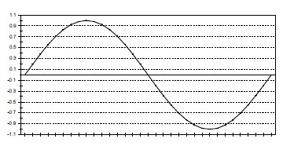

#### Fig.4.1 Sine wave

The frequency of the harmonics is different, depending on the fundamental frequency. For example, the 2nd harmonic on a 60 Hz system is 2*60 or 120 Hz. At 50Hz, the second harmonic is 2* 50 or 100Hz.

300Hz is the 5th harmonic in a 60 Hz system, or the 6th harmonic in a 50 Hz system.

Figure 2 shows how a signal with two harmonics would appear on an oscilloscope-type display, which some power quality analyzers provide.

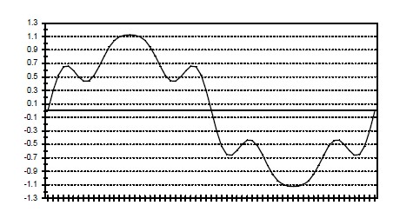

#### Figure.4.2 Fundamental with two harmonics

In order to be able to analyze complex signals that have many different frequencies present, a number of mathematical methods were developed. One of the more popular is called the Fourier Transform. However, duplicating the mathematical steps required in a microprocessor or computer-based instrument is quite difficult. So more compatible processes, called the FFT for Fast Fourier transform or DFT for Discrete Fourier Transform are used.

These methods only work properly if the signal is composed of only the fundamental and harmonic frequencies in a certain frequency range (called the Nyquist frequency, which is one-half of the sampling frequency). The frequency values must not change during the measurement period. Failure of these rules to be maintained can result in mis-information. For example, if a voltage waveform is comprised of 60 Hz and 200 Hz signals, the FFT cannot directly see the 200 Hz. It only knows 60, 120, 180, 240.... which are often called “bins”. The result would be that the energy of the 200 Hz signal would appear partially in the 180Hz bin, and partially in the 240 Hz bin. An FFT-based processer could show a voltage value of 115V at 60 Hz, 18 V at the 3rd harmonic, and 12 V at the 4th harmonic, when it really should have been 30 V at 200 Hz.

These in-between frequencies are called “inter harmonics”. There is also a special category of inter harmonics, which are frequency values less than the fundamental frequency value, called sub-harmonics. For example, the process of melting metal in an electric arc furnace can result large currents that are comprised of the fundamental , inter harmonic, and sub harmonic frequencies being drawn from the electric power grid. These levels can be quite high during the melt-down phase, and usually effect the voltage waveform.

**4.1 Why Worry About Them**

The presence of harmonics does not mean that the factory or office cannot run properly. Like other power quality phenomena, it depends on the “stiffness” of the power distribution system and the susceptibility of the equipment. As shown below, there are a number of different types of equipment that can have mis operations or failures due to high harmonic voltage and/or current levels. In addition, one factory may be the source of high harmonics but able to run properly. This harmonic pollution is often carried back onto the electric utility distribution system, and may effect facilities on the same system which are more susceptible. Some typical types of equipment susceptible to harmonic pollution include: - Excessive neutral current, resulting in overheated neutrals. The odd triplen harmonics in three phase wye circuits are actually additive in the neutral. This is because the harmonic number multiplied by the 120 degree phase shift between phases is an integer multiple of 360 degrees. This puts the harmonics from each of the three phase legs “in-phase” with each other in the neutral, as shown in Figure 3.

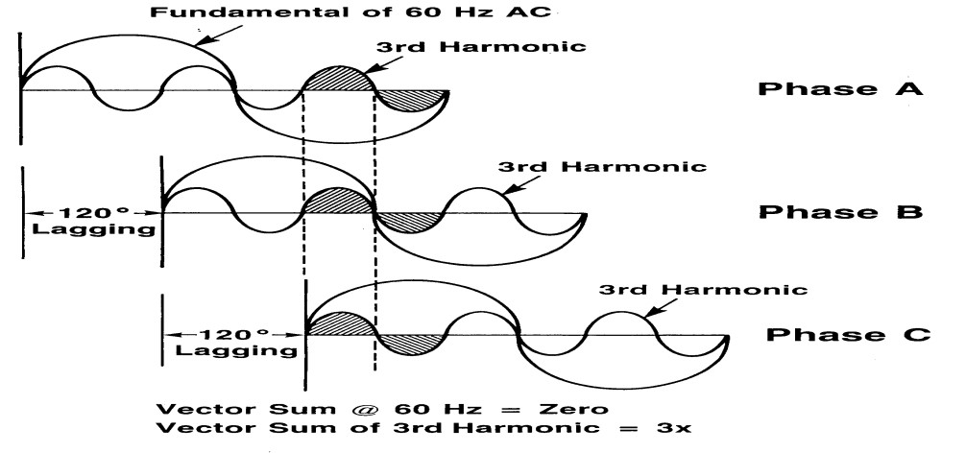

#### Figure.4.3 Additive Third Harmonics

* Incorrect reading meters, including induction disc W-hr meters and averaging type current meters.
* Reduced true PF, where PF= Watts/VA.
* Overheated transformers, especially delta windings where triplen harmonics generated on the load side of a delta-wye transformer will circulate in the primary side. Some type of losses go up as the square of harmonic value (such as skin effect and eddy current losses). This is also true for solenoid coils and lighting ballasts.
* Zero, negative sequence voltages on motors and generators. In a balanced system, voltage harmonics can either be positive (fundamental, 4th, 7th....), negative (2nd, 5th, 8th...) or zero (3rd, 6th, 9th....) sequencing values. This means that the voltage at that particular frequency tries to rotate the motor forward, backward, or neither (just heats up the motor), respectively. There is also heating from increased losses as in a transformer.

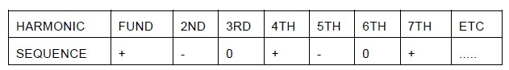

Table.4.1 Harmonic Sequencing Values in Balanced Systems

* Nuisance operation of protective devices, including false tripping of relays and failure of a UPS to transfer properly, especially if controls incorporate zero-crossing sensing circuits.
* Bearing failure from shaft currents through uninsulated bearings of electric motors. - Blown-fuses on PF correction caps, due to high voltage and currents from resonance with line impedance.
* Mis-operation or failure of electronic equipment
* If there are voltage sub harmonics in the range of 1-30Hz, the effect on lighting is called flicker. This is especially true at 8.8Hz, where the human eye is most sensitive, and just

0.5% variation in the voltage is noticeable with some types of lighting.

**4.2 Where They Come From**

How this electricity is used by the different type of loads can have an effect on “purity” of the voltage waveform. Some loads cause the voltage and current waveforms to lose this pure sine wave appearance and become distorted. This distortion may consist of predominately harmonics, depending on the type of load and system impedances. Since this article is about harmonics, we will concentrate on those types of sources. “The main sources of harmonic current are at present the phase angle controlled rectifiers and inverters.” These are often called static power converters. These devices take AC power and convert it to another form, sometimes back to AC power at the same or different frequency, based on the firing scheme. The firing scheme refers to the controlling mechanism that determines how and when current is conducted. One major variation is the phase angle at which conduction begins and ends. A typical such converter is the switching-type power supplies found in most personal computers and peripheral equipment, such as printers. While they offer many benefits in size, weight and cost, the large increase of this type of equipment over the past fifteen years is largely responsible for the increased attention to harmonics. Figure shows below how a switching-type power supply works. The AC voltage is converted into a DC voltage, which is further converted into other voltages that the equipment needs to run. The rectifier consists of semi-conductor devices (such as diodes) that only conduct current in one direction. In order to do so, the voltage on the one end must be greater than the other end. These devices feed current into a capacitor, where the voltage value on the cap at any time depends on how much energy is being taken out by the rest of the power supply. When the input voltage value is higher than voltage on the capacitor, the diode will conduct current through it. This results in a current waveform as shown in Figure 5, and harmonic spectrum in Figure 6. Obviously, this is not a pure sinusoidal waveform with only a 60 Hz frequency component.

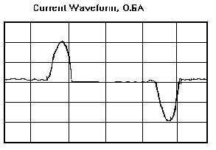

#### Fig. 4.4 Current Waveform

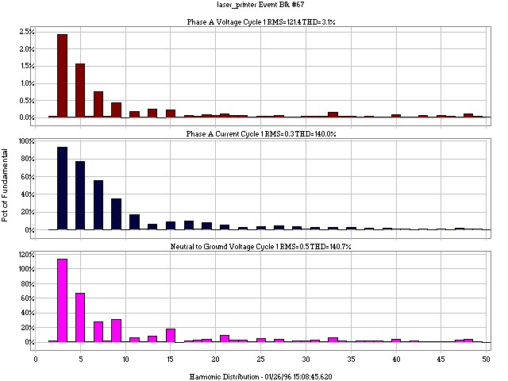

Fig. 4.5 Harmonic Spectrum of Current Waveform Shown in Figure 4.4

If the rectifier had only been a half wave rectifier, the waveform would only have every other current pulse, and the harmonic spectrum would be different, as shown in Figure 7.

Fluorescent lights can be the source of harmonics, as the ballasts are non-linear inductors. The third harmonic is the predominate harmonic in this case. (See Table 3) As previously mentioned, the third harmonic current from each phase in a four-wire wye or star system will be additive in the neutral, instead of cancelling out Some of the newer electronic ballasts have very significant harmonic problems, as they operate somewhat like a switching power supply, but can result in current harmonic distortion levels over 30%.

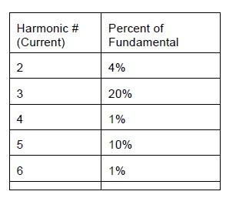

#### Table 4.2. Sample of Harmonic Values for Fluorescent lighting

Low power, AC voltage regulators for light dimmers and small induction motors adjust the phase angle or point on the wave where conduction occurs. Medium power converters are used for motor control in manufacturing and railroad applications, and include such equipment as ASDs (adjustable speed drives) and VFDs (variable frequency drives). Metal reduction operations, like electric arc furnaces, and high voltage DC transmission employ large power converters, in the 2-20MVA rating. This type of 3phase equipment may also cause other types of power quality problems. When the semiconductor device is suppose to turn-off, it does not do so abruptly. This happens under “naturally” commutated conditions, where the voltage that was larger on the anode side compared to the cathode is now the opposite. This occurs each cycle as the voltage waveform goes through the sine waveform. It also happens under “forced” commutation conditions, where the semi-conductor device has a “gate”-type control mechanism built in to it. This commutation period is a time when two semiconductor devices are both conducting current at the same time, effectively shorting one phase to the other and resulting in large current transients. When transformers are first energized, the current drawn is different from the steady state condition. This is caused by the inrush of the magnetizing current. The harmonics during this period varies over time. Some harmonics have zero value for part of the time, and then increase for a while before returning to zero. An unbalanced transformer (where either the output current, winding impedance or input voltage on each leg are not equal) will cause harmonics, as will overvoltage saturation of a transformer.

**4.2.1 Where to look for them**

Wherever the aforementioned equipment is used, one can suspect that harmonics are present. The amount of voltage harmonics will often depend on the amount of harmonic currents being drawn by the load, and the source impedance, which includes all of the wiring and transformers back to the source of the electricity. Ohm‟s Law says that Voltage equals Current multiplied by Impedance. This is true for harmonic values as well. If the source harmonic impedance is very low (often referred to as a “stiff” system) then the harmonic currents will result in lower harmonic voltages than if the source impedance were high (such as found with some types of isolation transformers).Like any power quality investigation, the search can begin at the equipment effected by the problem or at the point-of-common-coupling (PCC), where the utility service meets the building distribution system. If only one piece of equipment is effected (or suspected), it is often easier to start the monitoring process there. If the source is suspected to be from the utility service side (such is the case when there is a neighboring factory that is known to generate high harmonics), then monitoring usually begins at the PCC. The phase voltages and currents, as well as the neutral-to-ground voltage and neutral current should be monitored, where possible. This will aid in pinpointing problems, or detecting marginal systems. Monitoring the neutral will often show a high 3rd harmonic value, indicating the presence of non-linear loads in the facility.

**4.2.2 How do you find them?**

Hand-held harmonic meters can be useful tools for making spot checks for known harmonic problems. However, harmonic values will often change during the day, as different loads are turned on and off within the facility or in other facilities on the same electric utility distribution system. This requires the use of a harmonic monitor or power quality monitor with harmonic capabilities (such as shown in Figure 8), which can record the harmonic values over a period of time.

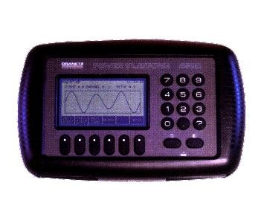

#### Figure 4.6 Power Quality Monitor with Harmonic Analysis

Typically, monitoring will last for one business cycle. A business cycle is how long it takes for the normal operation of the plant to repeat itself. For example, if a plant runs three identical shifts, seven days a week, then a business cycle would be eight hours. More typically, a business cycle is one week, as different operations take place on a Monday, when the plant equipment is restarted after being off over the weekend, then on a Wednesday, or a Saturday, when only a Skelton crew may be working. Certain types of loads also generate typical harmonic spectrum signatures that can point the investigator towards the source. This is related to the number of pulses, or paths of conduction. The general equation is h = (n * p) +/- 1, where h is the harmonic number, n is any integer (1, 2, 3...) and p is the number of pulses in the circuit, and the magnitude decreases as the ration of 1/h (1/3, 1/5, 1/7, 1/9...). Table 4 shows examples of such.

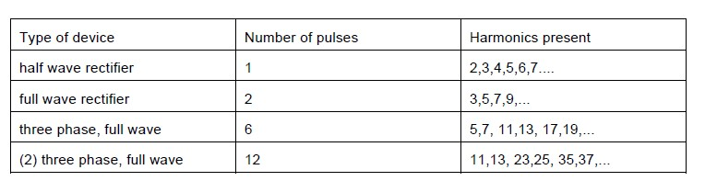

Table 4.3 Typical Harmonics Found for Different Converters.

**4.3 When are they a problem?**

Most electrical loads (except half-wave rectifiers) produce symmetrical current waveforms, which mean that the positive half of the waveform looks like a mirror image of the negative half. This results in only odd harmonic values being present. Even harmonics will disrupt this half-wave symmetry. The presence of these even harmonics should cause the investigator to suspect there is a half-wave rectifier on the circuit. This also results from a full wave rectifier when one side of the rectifier has blown or damaged components. Early detection of this condition in a UPS system can prevent a complete failure when the load is switched onto back-up power. To determine what is normal or acceptable levels, a number of standards have been developed by various organizations. ANSI/IEEE C57.110 Recommended Practice for Establishing Transformer Compatibility When Supplying No sinusoidal Load Currents is a useful document for determining how much a transformer should be derated from its nameplate rating when operating in the presence of harmonics. There are two parameters typically used, called K-factor and TDF

(transformer de reading factor). Some power quality harmonic monitors will automatically calculate these values. IEEE 519-1992 Recommended Practices and Requirements for Harmonic Control in Electrical Power Systems provides guidelines from determining what acceptable limits are. The harmonic limits for current depend on the ratio of Short Circuit Current (SCC) at PCC (or how stiff it is) to average Load Current of maximum demand over 1 year, as illustrated in Table 5. Note how the limit decreases at the higher harmonic values, and increases with larger ratios.

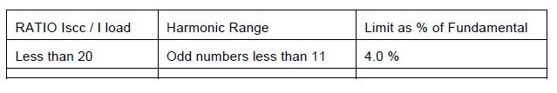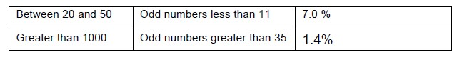

Table 4.4 Current Harmonic Limits as per IEEE 519-1992

For voltage harmonics, the voltage level of the system is used to determine the limits, as shown in Table 6. At the higher voltages, more customers will be effective, hence, the lower limits.

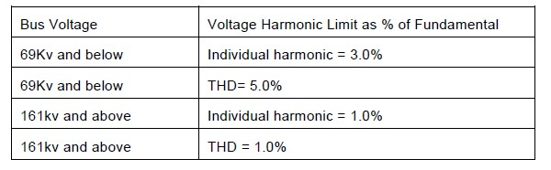

Table 4.4 Voltage Harmonic Limits as per IEEE 519-1992

The European Community has also developed susceptibility and emission limits for\ harmonics. Formerly known as the 555-2 standard for appliances of less than 16 A, a more encompassing set of standards under IEC 1000-4-7 are now in effect.

**4.4 How do you get rid of them?**

Care should be undertaken to make sure that the corrective action taken to minimize the harmonic problems don‟t actually make the system worse. This can be the result of resonance between harmonic filters, PF correcting capacitors and the system impedance. Isolating harmonic pollution devices on separate circuits with or without the use of harmonic filters are typical ways of mitigating the effects of such. Loads can be relocated to try to balance the system better. Neutral conductors should be properly sized according to the latest NEC-1996 requirements covering such. Whereas the neutral may have been undersized in the past, it may now be necessary to run a second neutral wire that is the same size as the phase conductors. This is particularly important with some modular office partition-type walls, which can exhibit high impedance values. The operating limits of transformers and motors should be derated, in accordance with industry standards from IEEE, ANSI and NEMA on such. Use of higher pulse converters, such as 24-pulse rectifiers, can eliminate lower harmonic values, but at the expense of creating higher harmonic values.

### 5. MATHEMATICAL MODEL OF DFIG UNDER HARMONICALLY DISTORTED VOLTAGE

In order to investigate the DPC strategy, DFIG mathematical model under harmonically distorted grid condition should be established first. Under the harmonically distorted grid condition, grid voltage can be decomposed into fundamental frequency component and a series of harmonic frequency components. Considering that the fifth- and seventh-order sequences are the major harmonic components of the grid voltage [12]; this project would focus on the DPC strategy under these two harmonic components. Fig. 1 shows the relationship of the fundamental and harmonic sequence coordinate frames, in which(dq) + is rotated at the speed of+ω1, (dq) 5− at the speed of –5ω1, (dq)7−at the speed of 7ω1.ω1is the synchronous angular speed of the fundamental frequency grid voltage. The equivalent circuit of DFIG in the (dq) + reference frame is shown in Fig. 2, in which DFIG stator flux ψ + sdq and rotor fluxψ + rdq can be presented respectively as



Where ψis the flux, Iis the current, subscripts d,q represent components at the d,q axes, subscripts s, r represent stator and rotor components of DFIG, superscripts+represents the (dq) + reference frames rotating at the angular speed of +ω1.

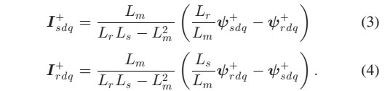

Ls =Lδs+Lm and Lr =Lδr+Lmare total self-inductances of stator and rotor winding,Lδs,Lδr, and L mare stator and rotor leakage inductances and the mutual inductance, respectively. Based on (1) and (2), the stator current and rotor current can be written as

According to Fig. 2, the stator and rotor voltages U+ sdq and U+rdq in the (dq) + reference frame can be expressed as

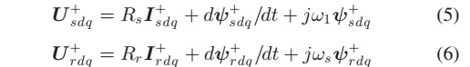

Where U is the voltage, Rs and Rr are stator and rotor resistances, ωr is the rotor angular speed, and ωs=ω1–ωr is the slip angular speed. DFIG stator output instantaneous active and reactive powers can be expressed as

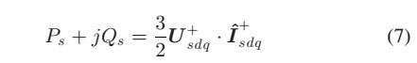

Where I+sdq is the conjugated space vector of I + sdq,Ps, and Qs are stator active and reactive power. When the d-axis of the synchronous reference frame is aligned with the stator voltage vector, the deferential of stator flux ψ + sdq will be zero. And assuming that the stator resistance is ignored, (5) can be written as



Substituting (6) and (8) into (7), the stator active and reactive powers can be yielded as

Where

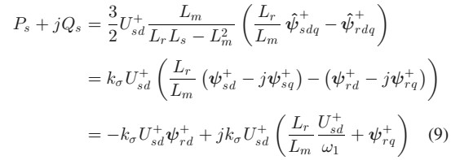

Therefore, the stator active power and reactive power can be written respectively as





Based on (10), the rotor flux can be shown as

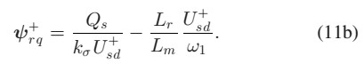

Equation (6) can be separated into d-axis and q-axis component and rewritten as

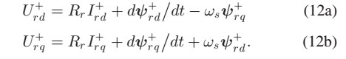

Substituting (4) and (11a) into (12a), rotor voltage *d*-axis component in the *(dq)*+ reference frame can be written as

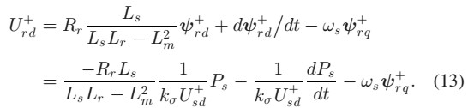

The last item of (13) is an equivalent rotor back electromagnetic force which can be regarded as compensation item. Thus, the transfer function of stator output active power to the rotor voltage d-axis component can be expressed as

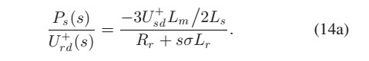

Similar mathematical deduction can be conducted to obtain the transfer function of stator output reactive power to rotor voltage q-axis component, which is shown as following:

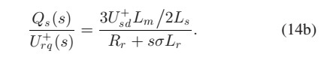

Besides, based on (11), during a constant sampling time period Ts, the deferential of rotor flux can be calculated as

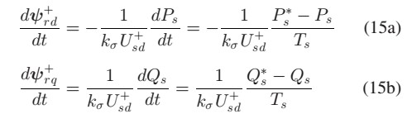

Where, Ps and Qs are the stator active and reactive power references, respectively. Substituting (11) and (15) into (12), and neglecting the rotor resistance, the rotor control reference voltage for the DFIG control based on DPC can be written as

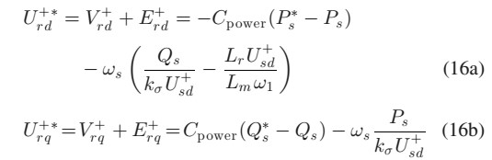

Where, C power is the proper stator power regulator to restrain the power regulation error. Equation (16) gives out that the rotor control voltage consists of the stator active and reactive power regulator output V+rdq and the back electromagnetic force E+rdq. It would be essential to choose the proper regulator C power to achieve zero power tracking error under the distorted grid voltage. Under the distorted grid voltage, the stator voltage contains not only fundamental, but also the fifth- and seventh-order harmonic components, which would produce the corresponding

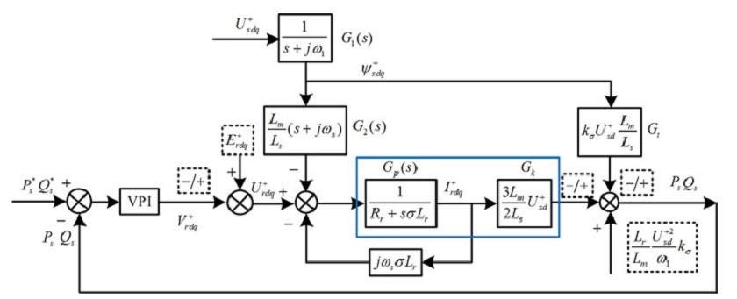

Fig. 5.1 DPC scheme of the DFIG under the distorted grid voltage using the VPI regulator.

harmonic components in the stator current; therefore, the 300 Hz stator output active and reactive power pulsation will be produced as a consequence [13]–[15]. For the sake of restraining the power pulsation item, the resonant regulator, which can be designed to have large control gain at the pulsation frequency (300 Hz), will be proposed for the DPC strategy of DFIG under the harmonic grid condition. Up to now, the PIR and VPI regulators are available for DFIG control under distorted grid voltage conditions to regulate the average and pulsation power item simultaneously. Considering that the VPI regulator has the advantage of pole-zero cancellation to eliminate the unexpected peak in the closed-loop control response and comparatively larger closed-loop operation phase margin (which would be proved in Section III), the VPI regulator is proposed for the power control of the DFIG under the harmonic voltage; thus, (16) can be modified as

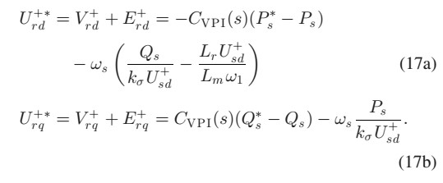

Equation (17) indicates that both the average component and 300 Hz pulsation component of stator active and reactive power errors can be suppressed to zero, and consequently, the power pulsation can be eliminated when the constant active or reactive power references are given.

#### **5.1 PERFORMANCE ANALYSIS OF THE DPC STRATEGY WITH A VPI REGULATOR**

In order to achieve the smooth stator active and reactive power output under the distorted grid voltage, the DFIG steady and dynamic state performance, as well as the disturbance rejection capability of the proposed DPC strategy using the VPI regulator should be investigated. Moreover, as the conventional PIR regulator would cause the deterioration of closed-loop control phase margin and may cause instability operation; the closed-loop stability using the VPI regulator should also be discussed. Based on (5), the stator flux in the (dq) + reference frame can be obtained as



If the stator resistance Rs is neglected, (18) can be simplified As



According to (1) and (2), the rotor flux in the (dq) + reference frame can be expressed as



Based on (6) and (20), the rotor voltage in the (dq)+ reference frame can be deduced as

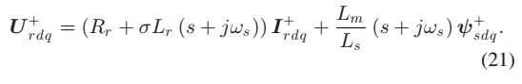

Therefore, based on (10), (19), (20), and (21), the proposed DPC scheme of the DFIG under the distorted grid voltage can be shown in Fig. 3, in which it can be seen: 1) the back EMF item E+rd andE+ rq of stator active power and reactive power can be found in

(17); 2) the Ps and Qs calculation and the VPI regulator output V +rdq can be found in (10) and (17);

3) The item kσLrU +2 sd ω1Lmis required for Qs calculation. Furthermore, the Gp(s) and Gk can be described as the mathematical model of DFIG, which can also be verified according to (14).

The transfer function of VPI regulator can be defined as [21], [22]

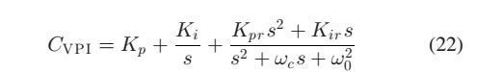

Where Kp and Ki are proportional and integral coefficient, respectively, for regulating the dc component, ωc is the resonant bandwidth,ω0is the resonant frequency. Kpr and Kir are proportional and integral coefficient of VPI for regulating the harmonic components, in which Kir =KprRr/σLr should be achieved based on the rule of pole-zero cancellation [22].

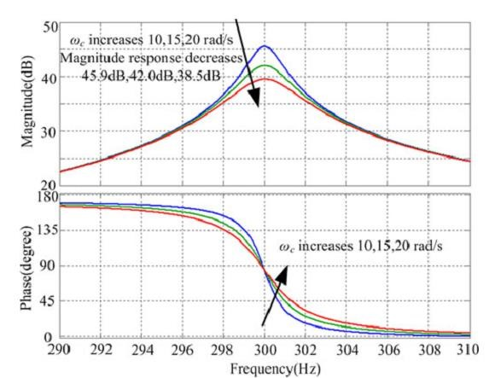

##### (a)

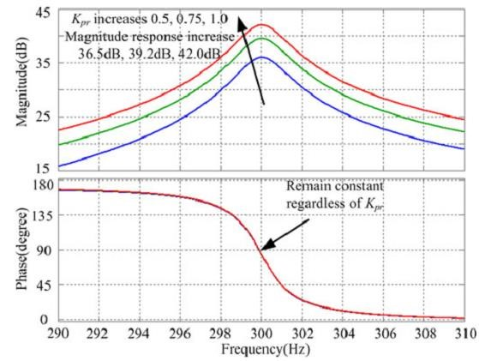

##### (b)

Fig.5.2 Bode diagram of the VPI regulator (a) *Kpr* = 1(*Kir* = 157), *ωc* = 10, 15, 20 rad/s; (b) *Kpr* = 0.5, 0.75, 1.0(*Kir* = 78.5, 117.75, 157), and *ωc* = 15 rad/s.

For the purpose of better investigating the proposed DPC strategy, it should be pointed out that Kpr,Kir, and ωc are the only parameters of the VPI regulator that can be adjusted in the control loop, while the other parameters such asω0 and DFIG machine parameters are fixed. Usually, ωc should be selected about 10–20 rad/s to improve the resonant peak gain and the robust performance to the grid frequency variation, and Kpr, Kir should be selected based on the rule of pole-zero cancellation to achieve the 30–50 dB peak gain at the resonant frequency to eliminate ac signal tracking error [23]–[26]. Fig. 4(a) shows the bode diagram of the VPI regulator with different resonant band width ωc =10, 15, 20 rad/s and same Kpr =1.0(Kir =157). The magnitude at the resonant frequency 300 Hz would be 45.9, 42.0, and 38.5 dB, which is large enough to minimize the control error. And the magnitude response at the frequency adjacent to the resonant frequency would remain almost constant regardless of ωc. Moreover, it should be pointed out that the VPI regulator phase response at 300 Hz would be phase leading of around 90◦, which is more beneficial to the control of the DFIG behaving as an inertia unit. Fig. 4(b) shows the bode diagram of the VPI regulator with different Kpr =0.5, 0.75, 1.0(Kir =78.5, 117.75, 157) and same resonant bandwidth ωc =15 rad/s. It can be seen that the magnitude at the resonant frequency 300 Hz would be 36.5, 39.2, and 42.0 dB. Nevertheless, the magnitude response at the adjacent frequency would become lower than the results in

Fig. 4(a), while the phase response remains constant regardless of ωc. The magnitude and phase response at the resonant 300 Hz frequency are mostly important for the harmonic current control of the DFIG. In Fig. 4, it can be found that, under the condition of Kpr and ωc variation, the magnitude response would vary within an acceptable range of 30– 50 dB so that the satisfactory ac signal tracking error can be ensured, and the phase response would remain unchanged of around leading 90◦ which is favorable to the control of the DFIG as an inertia unit.

**5.2** **Steady-state Performance**

According to Fig. 3, the transfer function of stator active and reactive power reference

Ps, Qs to actual power Ps Qs can be obtained as following, in which the back EMFE+rdq and grid voltage + sdq is regarded as disturbance and neglected

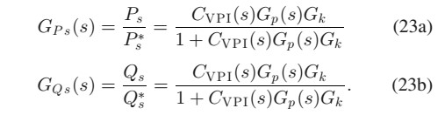

Fig. 5 shows the closed-loop control bode diagram with the same parameters in Fig. 4. As shown in Fig. 5(a), with Kpr =1(Kir =157) and ωc =10, 15, and 20 rad/s, the magnitude response of GPs(s) and GQs(s)at the dc and 300 Hz point is 0 dB, and the phase response at the dc and 300 Hz point is 0◦, which indicates that the actual stator active and reactive power would accurately follow the reference signal. The closed-loop control bode diagram with Kpr=0.5, 0.75, 1.0(Kir =78.5, 117.75, 157) and ωc =15 rad/s is shown in Fig. 5(b). The magnitude and phase response of GPs(s) and GQs(s)at the frequency lower than 300 Hz would be different from the results in Fig. 5(a), while the same magnitude and phase response will be achieved at the resonant frequency 300 Hz, which ensure the accurate tracking of both dc component and 300 Hz ac component with 0 dB magnitude response and 0◦ phase response. Therefore, it can be obtained that the closed-loop control steady-state performance of the proposed DPC strategy with the VPI regulator would be satisfactorily accurate regardless of the parameter Kpr and ωc variation.

**5.3** **Dynamic Performance Analysis**

It is also important to make comparison of dynamic response between the proposed DPC and traditional VOC for the DFIG control under the harmonic voltage. The dynamic performance with the proposed DPC strategy can be investigated based on

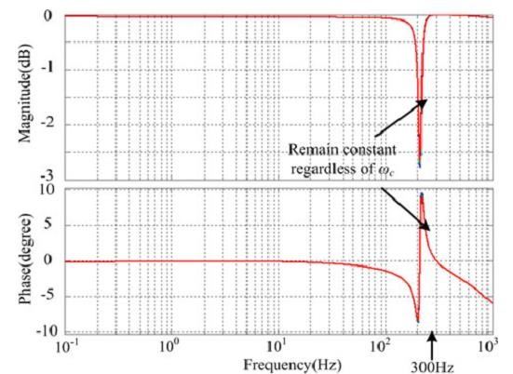

##### (a)

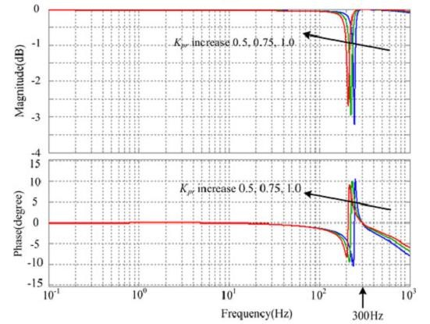

##### (b)

Fig. 5.3 Bode diagram of *GP s* (*s*) and *GQ s* (*s*) with different parameters: (a) *Kpr* = 1(*Kir* = 157), *ωc* = 10, 15, 20 rad/s; (b) *Kpr* = 0.5, 0.75, 1.0(*Kir* = 78.5, 117.75, 157), *ωc* = 15 rad/s; (*Kp* = 1, *Ki* = 1, *ωc* = 10 rad/s, *ω*0 = 600*π* rad/s, *U*+ *sd* = 110 V, *Rr* = 0.88 Ω, *Ls* =

*Lr* = 0.093 H, *Lm* =

0.09 H, *σ* = 0.063).

The stator active and reactive power closed-loop control transfer function as shown in (23). According to [13], considering that the DFIG plant transfer function using the VOC strategy can be expressed identically as Gp(s) in Fig. 3, the major difference between

DPC and VOC for the dynamic performance analysis would rely on the different DFIG plant transfer function when the same VPI regulator is adopted. Based on [13], the rotor current closed-loop control transfer function with VOC can be expressed as following:

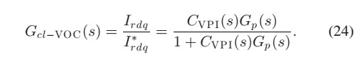

It can be seen that, in (23) and (24), the plant transfer function with DPC has one more item of Gk than that with VOC, which is helpful to enlarge the magnitude gain and widen the control frequency spectrum range.

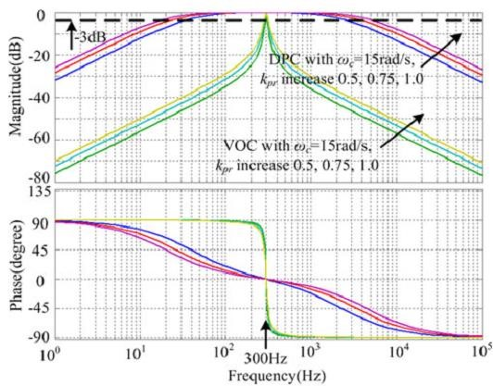

##### (a)

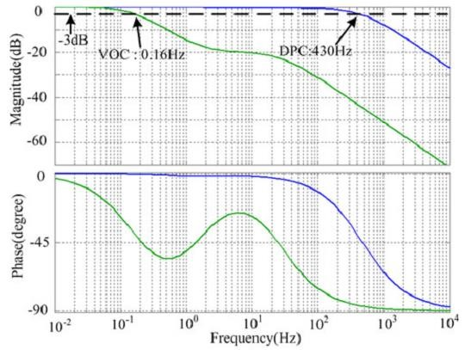

##### (b)

Fig. 5.4 Bode diagram of the closed-loop control transfer function under VOC and DPC strategy: (a) concerning the 300 Hz ac signal, *Kpr* = 0.5, 0.75, 1.0(*Kir* = 78.5, 117.75, 157), *ωc* = 15 rad/s; *ω*0 = 600*π* rad/s, *Usd*+ = 110 V, *Rr* = 0.88 Ω, *Ls* = *Lr* = 0.093 H, *Lm*

= 0.09 H, *σ* = 0.063; (b) concerning dc signal, *Kp* = 0.1, *Ki* = 1, *Usd*+ = 110 V, *Rr* = 0.88 Ω, *Ls* = *Lr* = 0.093 H, *Lm* = 0.09 H, *σ* = 0.063.

The bode diagram of the closed-loop control transfer function with VOC and DPC strategy is given in Fig. 6. Considering that the cut-off frequency should be with –3 dB magnitude response and larger cutoff frequency is helpful for the faster dynamic performance, the effective frequency spectrum with the VOC strategy would be 285 to 315 Hz as shown in Fig. 6(a), while the effective frequency spectrum with the DPC strategy would be 20 to 5000 Hz. It also can be seen that the VPI parameter variation of kpr 0.5, 0.75, and 1.0 has negligible influence on the dynamic performance of both the VOC and DPC strategy. Similar conclusion can be drawn when considering the dc signal regulation in Fig. 6(b). When VOC is adopted,−3 dB magnitude response would be obtained at the frequency of 0.16 Hz, and the corresponding cutoff frequency for DPC would be 430 Hz, which points out that the DPC would exhibit much faster dynamic response with the step change of stator output active and reactive power.

**5.4 Rejection of Grid Voltage Distortion on the Stator Active and Reactive Power Steady-State Tracking Performance:**

According to the control scheme shown in Fig. 3, when the grid voltage distortion is considered, the following equation can be deduced:

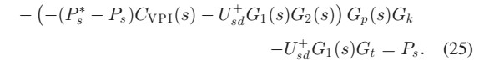

After the mathematical derivation, (25) can be rewritten as

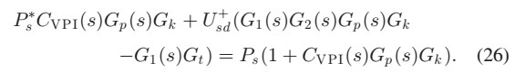

The stator active power reference Ps is usually constant, and the grid voltage d-axis U+sd contains the average fundamental component and fifth-/seventh-order harmonic components. Therefore, the constant stator active power reference P s and grid voltage fundamental components can be removed from (26), and the following equation can be deduced:

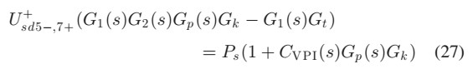

Then, the transfer function of grid voltage distorted component ***U***+*sd*5*−,*7+ to stator active power *Ps* can be given as

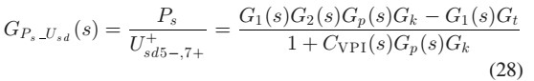

Fig. 7 demonstrates the grid voltage distortion rejection capability of the proposed DPC strategy with the consideration of the stator active power steady-state tracking performance. Fig. 7(a) exhibits the similar result as Fig. 5(a), i.e., when ωc varies as 10, 15, and 20 rad/s, the magnitude response at 300 Hz would change slightly as –59.7 dB, – 62.2 dB, and –65.7 dB, all of which would be large enough to attenuate the grid voltage distorted component. Besides, the phase response would also remain unchanged while ωc varies. As shown in Fig. 7(b) with Kpr=0.5, 0.75, 1.0(Kir =78.5, 117.75, 157) and ωc =15 rad/s, both the magnitude and phase response would change a little when the frequency is lower than 300 Hz. While at the 300 Hz frequency point, the magnitude and phase response would change slightly –56.2, –59.7, and –62.2 dB, which validates the satisfactory grid voltage distortion rejection capability on the stator active power tracking. Similarly, when considering the rejection of grid voltage distortion on the stator reactive power steady-state tracking performance, the high attenuation around –60 dB would also be guaranteed, which would not be discussed in detail. Thus, it can be concluded that the grid voltage distortion rejection capability of the proposed DPC strategy on the stator active and reactive power steady-state tracking performance would remain satisfactory regardless of the VPI regulator pa

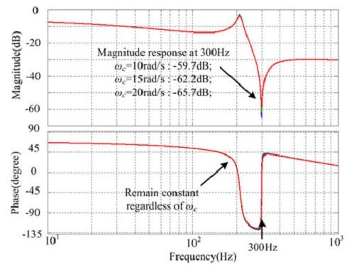

##### (a)

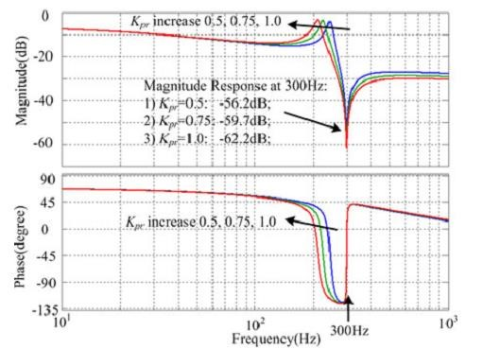

##### (b)

Fig. 5.5 Bode diagram of *GP s Usd* (*s*) with different parameters: (a) *Kpr* =1(*Kir* = 157), *ωc* = 10, 15, 20 rad/s; (b) *Kpr* = 0.5, 0.75, 1.0(*Kir* = 78.5,117.75, 157), *ωc* = 15 rad/s; (*Kp* = 1, *Ki* = 1, *ω*0 = 600*π* rad/s, *Usd*+ = 110 V, *Rr* = 0.88 Ω, *Ls* = *Lr* = 0.093 H, *Lm* = 0.09 H, *σ* = 0.063). rameter deviation, which results in the satisfactory stator active and reactive power accurate tracking performance.

**5.4.1 Stability Consideration**

It can be found in (23) and (28) that the denominators are the same which is always defined as characteristic equation of the closed-loop transfer function using the proposed DPC strategy. Thus, the transfer function used to verify the closed loop operation stability can be written as



The closed-loop control stability consideration under the proposed DPC strategy can be found from Fig. 8. It can be seen in Fig. 8(a) that, the magnitude and phase response would remain almost same at the resonant frequency 300 Hz when ωc varies 10, 15, and 20 rad/s, the same results can be found in Fig. 8(b) when Kpr varies 0.5, 0.75, and 1.0 as shown. Therefore, it can be concluded that the stable closed-loop operation of the proposed DPC strategy using the VPI regulator would always be guaranteed with sufficient phase margin of around 90◦for the stable closed-loop operation under the distorted grid voltage.

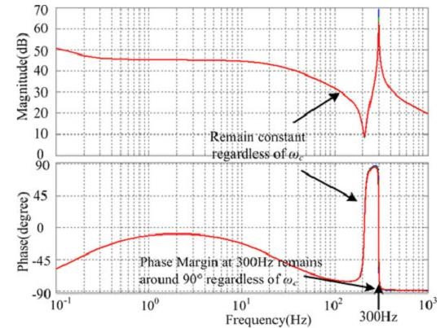

##### (a)

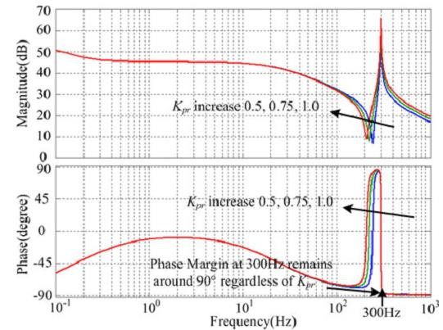

##### (b)

Fig. 5.6 Bode diagram of*D*(*s*) with different parameters: (a) *Kpr* = 1(*Kir* = 157), *ωc* = 10, 15, 20 rad/s; (b) *Kpr* = 0.5, 0.75, 1.0(*Kir* = 78.5, 117.75, 157), *ωc* = 15 rad/s; (*Kp* = 1, *Ki* = 1, *ωc* = 10 rad/s, *ω*0 = 600*π* rad/s, *Usd*+ = 110 V, *Rr* = 0.88 Ω, *Ls* = *Lr* = 0.093 H, *Lm*

= 0.09 H, *σ* = 0.063)

**5.5 Influence of Back EMF on the Steady-State Stator Active and Reactive Power Tracking Performances**:

As demonstrated in Fig. 3, the back EMF in (17) can be considered as a disturbance to the closed-loop operation; thus, the transfer function of back EMFd-axisE + rdto the stator active power Ps can be derived as

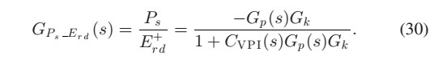

The back EMFd-axis component for the stator active powerControl



contains constant component of ωs, Qs, kσ, Lr, Lm and ω1, as well as 300 Hz

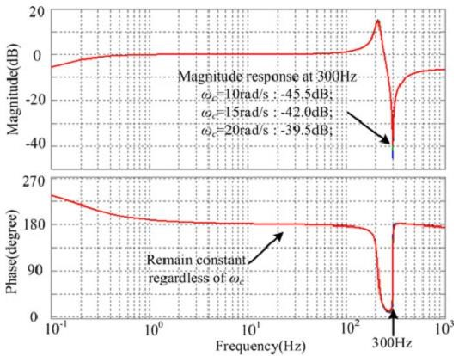

##### (a)

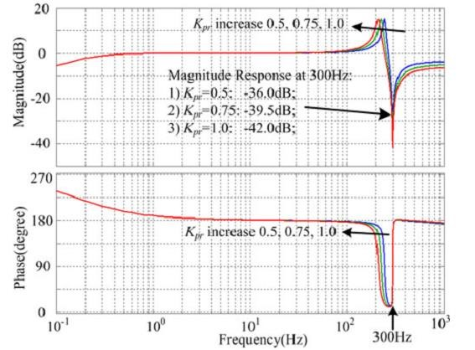

##### (b)

Fig. 5.7 Bode diagram of *GP s E rd* (*s*) with different parameters: (a) *Kpr* =1(*Kir* = 157), *ωc* = 10, 15, 20 rad/s; (b) *Kpr* = 0.5, 0.75, 1.0(*Kir* = 78.5, 117.75, 157), *ωc* = 15 rad/s;

(*Kp* = 1, *Ki* = 1, *ωc* = 10 rad/s, *ω*0 = 600*π*rad/s, *U*+*sd* = 110 V, *Rr* = 0.88 Ω, *Ls* = *Lr* =

0.093 H, *Lm* = 0.09 H, *σ* =

0.063).

a signal of grid voltage d-axis component U+sd containing fifth- and seventh-order harmonic components in the(dq) + frame. Fig. 9 shows the influence of back EMF d-axis E + rd on the steady-state stator active power tracking performance, where the 300 Hz harmonic signal would be significantly attenuated to –42.5, –42.0, and –39.5 dB with ωc =10, 15, and 20 rad/s in Fig. 9(a), or attenuated to –36.0, –39.5, and –42.0 dB with Kpr=0.5, 0.75, and 1.0 in Fig. 9(b) respectively. Therefore, it can be verified that the existence of back EMF d-axis component as compensation items would have negligible influence on the stator active power tracking precision. Similar conclusion concerning the influence of back EMF q-axis E+ rq on the steady-state stator reactive power tracking performance can also be obtained, which would not be described in detail

### 6. MATLAB

MATLAB is a high-performance language for technical computing. It integrates computation, visualization, and programming in an easy-to-use environment where problems and solutions are expressed in familiar mathematical notation. Typical uses include Math and computation Algorithm development Data acquisition Modeling, simulation, and prototyping Data analysis, exploration, and visualization Scientific and engineering graphics Application development, including graphical user interface building. MATLAB is an interactive system whose basic data element is an array that does not require dimensioning. This allows you to solve many technical computing problems, especially those with matrix and vector formulations, in a fraction of the time it would take to write a program in a scalar no interactive language such as C or FORTRAN.

The MATLAB stands for matrix laboratory. MATLAB was originally written to provide easy access to matrix software developed by the LINPAC and EISPACK projects. Today, MATLAB engines incorporate the LAPACK and blas libraries, embedding the state of the art in software for matrix computation. MATLAB has evolved over a period of years with input from many users. In university environments, it is the standard instructional tool for introductory and advanced courses in mathematics, engineering, and science. In industry, MATLAB is the tool of choice for highproductivity research, development, and analysis.

MATLAB features a family of add-on application-specific solutions called toolboxes. Very important to most users of MATLAB, toolboxes allow you to learn and apply specialized technology. Toolboxes are comprehensive collections of MATLAB functions (M-files) that extend the MATLAB environment to solve particular classes of problems. Areas in which toolboxes are available include signal processing, control systems, neural networks, fuzzy logic, wavelets, simulation, and many others.

**6.1 The MATLAB system consists of five main parts**:

Development Environment**:** This is the set of tools and facilities that help you use MATLAB functions and files. Many of these tools are graphical user interfaces. It includes the MATLAB desktop and Command Window, a command history, an editor and debugger, and browsers for viewing help, the workspace, files, and the search path. The MATLAB Mathematical Function Library: This is a vast collection of computational algorithms ranging from elementary functions, like sum, sine, cosine, and complex arithmetic, to more sophisticated functions like matrix inverse, matrix eigenvalues, Bessel functions, and fast Fourier transforms.

The MATLAB Language**:** This is a high-level matrix/array language with control flow statements, functions, data structures, input/output, and object-oriented programming features. It allows both "programming in the small" to rapidly create quick and dirty throw-away programs, and "programming in the large" to create large and complex application programs.

MATLAB has extensive facilities for displaying vectors and matrices as graphs, as well as annotating and printing these graphs. It includes high-level functions for twodimensional and three-dimensional data visualization, image processing, animation, and presentation graphics. It also includes low-level functions that allow you to fully customize the appearance of graphics as well as to build complete graphical user interfaces on your MATLAB applications.

The MATLAB Application Program Interface (API). This is a library that allows you to write C and Fortran programs that interact with MATLAB. It includes facilities for calling routines from MATLAB (dynamic linking), calling MATLAB as a computational engine, and for reading and writing MAT-files.

**6.2 SIMULINK:**

Simulink is a software add-on to MATLAB which is a mathematical tool developed by The Math works,(http://www.mathworks.com) a company based in Natick. MATLAB is powered by extensive numerical analysis capability. Simulink is a tool used to visually program a dynamic system (those governed by Differential equations) and look at results. Any logic circuit, or control system for a dynamic system can be built by using standard building blocks available in Simulink Libraries. Various toolboxes for different techniques, such as Fuzzy Logic, Neural Networks, dsp, Statistics etc. are available with Simulink, which enhance the processing power of the tool. The main advantage is the availability of templates / building blocks, which avoid the necessity of typing code for small mathematical processes.

**6.3 Concept of signal and logic flow:**

In Simulink, data/information from various blocks are sent to another block by lines connecting the relevant blocks. Signals can be generated and fed into blocks dynamic / static).Data can be fed into functions. Data can then be dumped into sinks, which could be scopes, displays or could be saved to a file. Data can be connected from one block to another, can be branched, multiplexed etc. In simulation, data is processed and transferred only at discrete times, since all computers are discrete systems. Thus, a simulation time step (otherwise called an integration time step) is essential, and the selection of that step is determined by the fastest dynamics in the simulated system.



#### Fig 6.1 Simulink library browser

**6.3.1 Connecting blocks:**

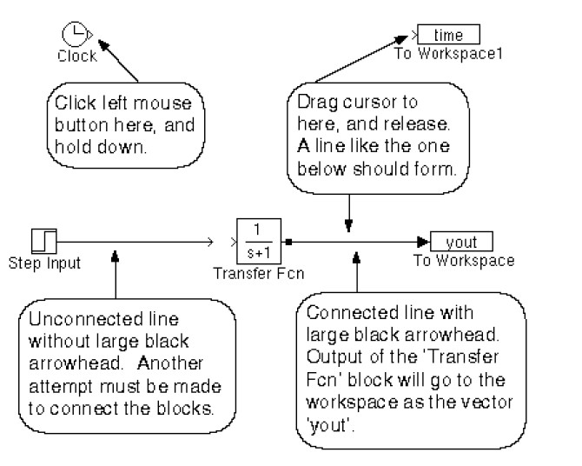 fig 6.2 Connecting blocks

To connect blocks, left-click and drag the mouse from the output of one block to the input

Of another block.

**6.3.2 Sources and sinks:**

The sources library contains the sources of data/signals that one would use in a dynamic system simulation. One may want to use a constant input, a sinusoidal wave, a step, a repeating sequence such as a pulse train, a ramp etc. One may want to test disturbance effects, and can use the random signal generator to simulate noise. The clock may be used to create a time index for plotting purposes. The ground could be used to connect to any unused port, to avoid warning messages indicating unconnected ports.

The sinks are blocks where signals are terminated or ultimately used. In most cases, we would want to store the resulting data in a file, or a matrix of variables. The data could be displayed or even stored to a file. The stop block could be used to stop the simulation if the input to that block (the signal being sunk) is non-zero. Figure 3 shows the available blocks in the sources and sinks libraries. Unused signals must be terminated, to prevent warnings about unconnected signals.

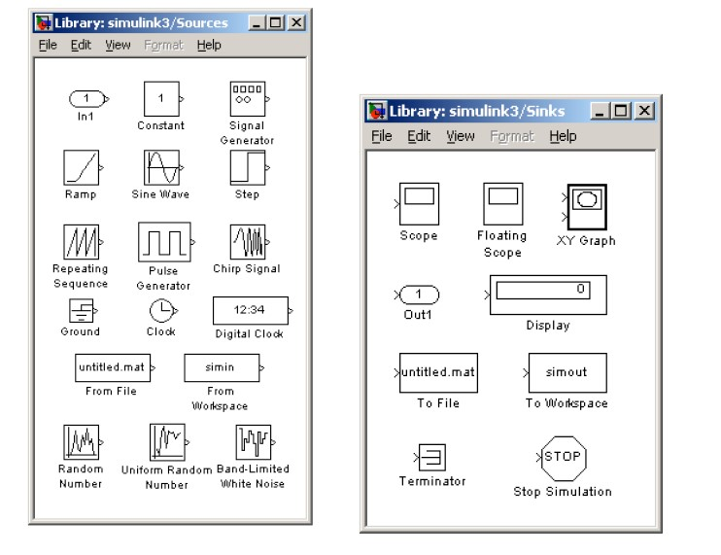

#### fig 6.3 Sources and sinks

**6.3.3 Continuous and discrete systems:**

All dynamic systems can be analyzed as continuous or discrete time systems. Simulink allows you to represent these systems using transfer functions, integration blocks, delay blocks etc.

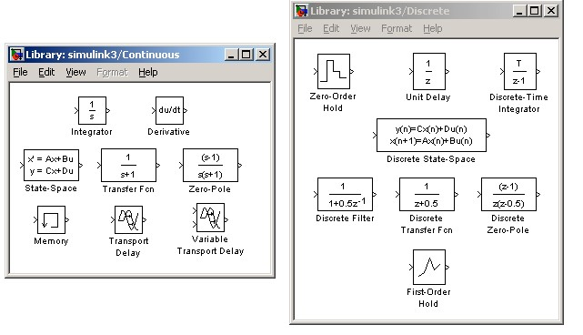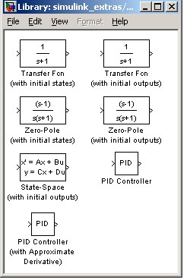

#### fig 6.4 continous and descrete systems

**6.3.4 Non-linear operators**

A main advantage of using tools such as Simulink is the ability to simulate nonlinear systems and arrive at results without having to solve analytically. It is very difficult to arrive at an analytical solution for a system having non-linearity such as saturation, signup function, limited slew rates etc. In Simulation, since systems are analyzed using iterations, non-linearity are not a hindrance. One such could be a saturation block, to indicate a physical limitation on a parameter, such as a voltage signal to a motor etc. Manual switches are useful when trying simulations with different cases. Switches are the logical equivalent of if-then statements in programming.

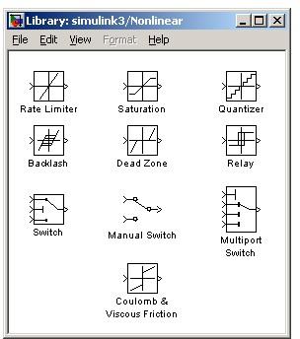 fig 6.5 simulink blocks

**6.4 Mathematical operations:**

Mathematical operators such as products, sum, logical operations such as and, or, etc. .can be programmed along with the signal flow. Matrix multiplication becomes easy with the matrix gain block. Trigonometric functions such as sin or tan inverse (at an) are also available. Relational operators such as „equal to‟, „greater than‟ etc. can also be used in logic circuits

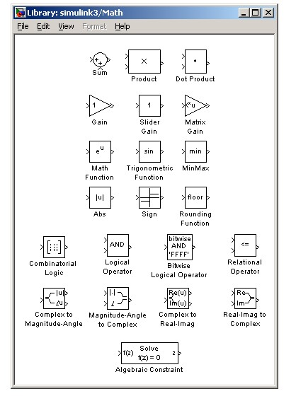

#### fig 6.6 Simulink math blocks

**6.4.1 SIGNALS & DATA TRANSFER:**

In complicated block diagrams, there may arise the need to transfer data from one portion to another portion of the block. They may be in different subsystems. That signal could be dumped into a go to block, which is used to send signals from one subsystem to another.

Multiplexing helps us remove clutter due to excessive connectors, and makes matrix (column/row) visualization easier.

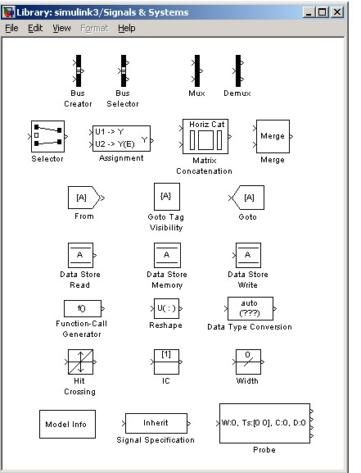 fig 6.7 signals and systems

**6.4.2 Making subsystems**

Drag a subsystem from the Simulink Library Browser and place it in the parent block where you would like to hide the code. The type of subsystem depends on the purpose of the block. In general one will use the standard subsystem but other subsystems can be chosen. For instance, the subsystem can be a triggered block, which is enabled only when a trigger signal is received. Open (double click) the subsystem and create input / output PORTS, which transfer signals into and out of the subsystem. The input and output ports are created by dragging them from the Sources and Sinks directories respectively. When ports are created in the subsystem, they automatically create ports on the external (parent) block. This allows for connecting the appropriate signals from the parent block to the subsystem.

**6.4.3 Setting simulation parameters:**

Running a simulation in the computer always requires a numerical technique to solve a differential equation. The system can be simulated as a continuous system or a discrete system based on the blocks inside. The simulation start and stop time can be specified. In case of variable step size, the smallest and largest step size can be specified. A Fixed step size is recommended and it allows for indexing time to a precise number of points, thus controlling the size of the data vector. Simulation step size must be decided based on the dynamics of the system. A thermal process may warrant a step size of a few seconds, but a DC motor in the system may be quite fast and may require a step size of a few milliseconds.

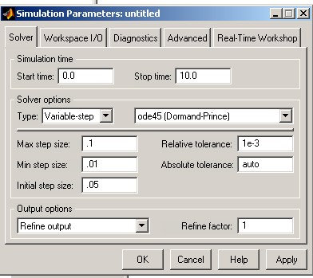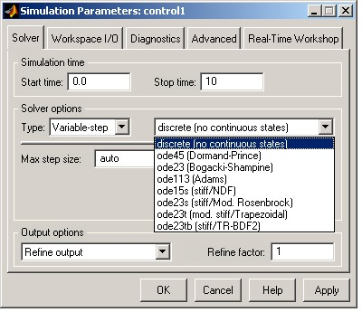

Fig.6.8 Sample parameters values

**Matlab Model:**

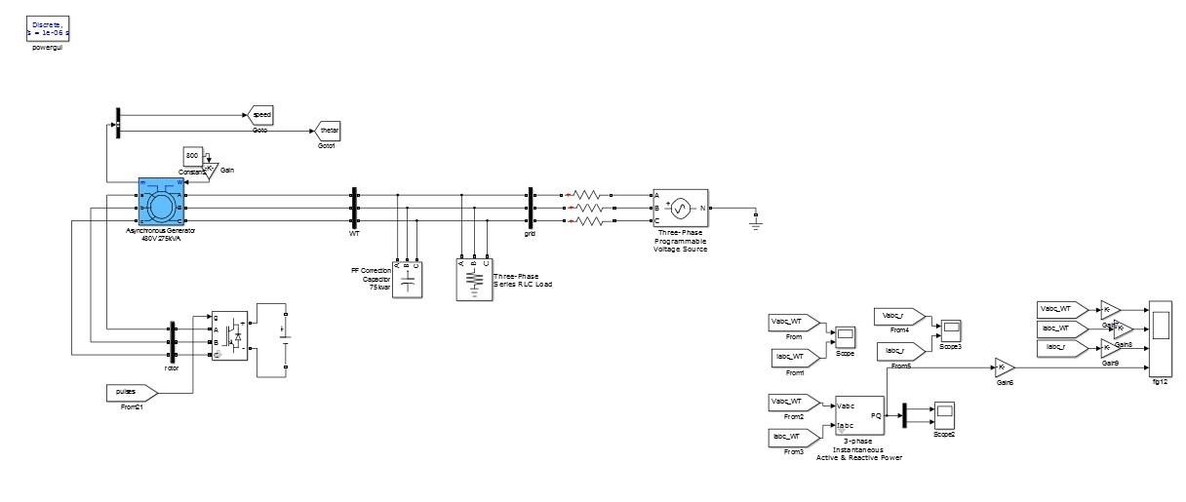

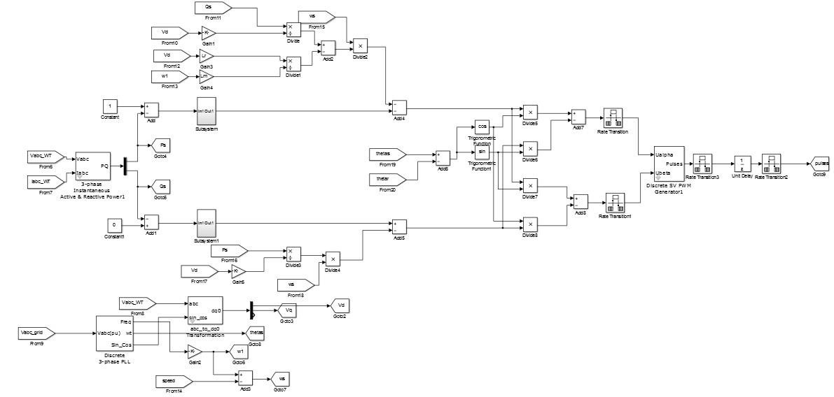

### 7. Experimental Setup

An experimental system was built on a laboratory prototype of 1 kW DFIG system as shown in Fig. 10, in which the DFIG is driven by a 1.5 kW squirrel cage induction machine as the wind turbine. The induction machine is driven by a general converter. The rotor side converter of DFIG is connected with a dc power supply. A controllable three-phase power grid is set up to simulate the practical harmonic power grid [28]. In the experiment, fifth- and seventh-order harmonic components are set to be 3.4% and 2.8% each, and the rotor speed is initially set to 800 rpm. The control strategy is implemented on the TI DSP TMS320F2812, and the driver for IGBT is SEMIKRON SKHI61. The sampling frequency is 10 kHz, and the IGBT switching frequency is 5 kHz. The waveforms are acquired by a YOKOGAWA DL750 scope recorder, the harmonic component analysis is done by FLUKE NORMA 5000 power analyzer.

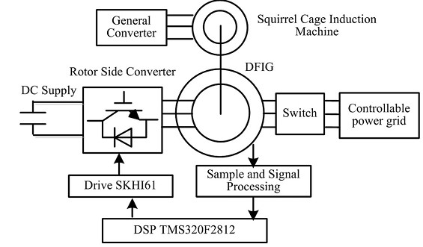

Fig. 7.1 Block diagram of experiment system.

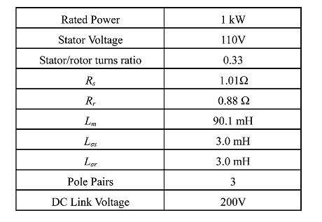

#### Table 7.1 Parameters of experimental setup

The proposed DPC control strategy for DFIG system under the distorted grid voltage is shown in Fig. 11. First, the grid voltage phase is obtained through phase lock loop (PLL) proposed in [13], the rotor position and speed are achieved by the output of an encoder.

The stator active and reactive powers can be calculated by sampling three-phase stator voltage and current. The stator active and reactive power control error, which is the input of the VPI regulator, can be calculated according to the

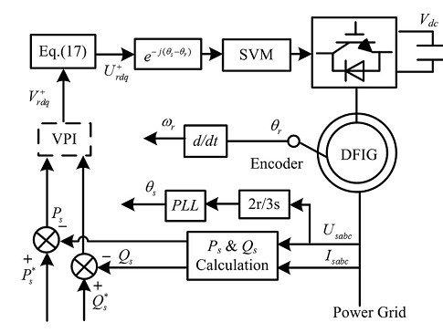

Fig.7.2 Proposed DPC scheme of DFIG under distorted grid voltage using the VPI regulator

actual signal and reference signal. The output of the VPI regulator, together with the compensation back electromagnetic force, would be sent to the SVPWM to generate the IGBT switching signals to fulfill the control target. The control target in this project is chosen as smooth stator output active and reactive power. It can be seen from the proposed DPC control strategy scheme that no harmonic decomposition is required during the control process, therefore no negative influence on the control system stability and fast dynamic response would be produced. However, it should be noted that the practical DFIG machine contains certain inevitable tooth harmonic, this would inevitably result in the nonsinusoidal air gap magnetic field and the corresponding stator and rotor harmonic current. Such nonsinusoidal components would always exist during the experiment, and it would help to better understand the proposed DPC strategy if these nosinusoidal components are considered as the background harmonics.

#### **7.2 Experimental Results**

During the experiment process, the VPI regulator is applied with the resonant bandwidth ωc =15 rad/s, the resonant parameter Kpr, and Kir is chosen as 1 and 157 based on the rule of pole-zero cancellation [21], [22]. The DFIG experiment result under ideal power grid (which still contains 0.80% and 0.34% fifth and seventh harmonic components) is shown in Fig. 12. The background harmonic components caused by the DFIG itself would results in the tiny nonsinusoidal components both in the stator and rotor currents, i.e., the fifth- and seventh-order harmonic component of the stator current is 2.13% and 0.54%, respectively. As a consequence, tiny stator active and reactive power 300 Hz pulsation would be produced,±18 W and±15 Var, due to the existence of nonsinusoidal stator current. The experimental result under the distorted grid voltage with fifth- and seventh-order harmonic components set as 3.40% and 2.80%, respectively, is carried out and shown in Fig. 13. The stator currents contain harmonic components of 7.52% 250 Hz and 3.69% 350 Hz due to the occurrence of the distorted grid voltage fifth and seventh harmonic components. Considering

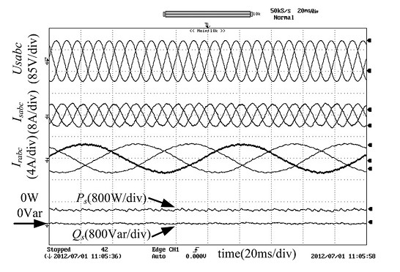

Fig. 7.3. Experimental result of the DFIG system performance under the ideal grid voltage condition.

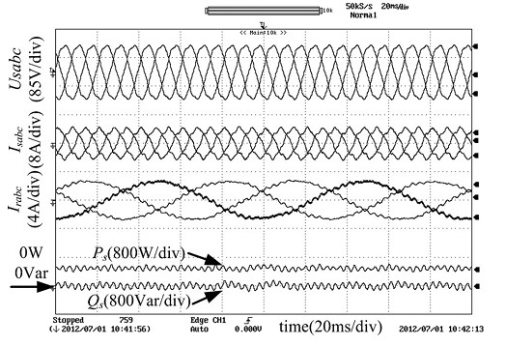

Fig. 7.4. Experimental result of the DFIG system performance under the distorted grid voltage condition with VPI disabled.

that the rotor speed is 800 rpm (0.8 p.u., equivalent to 40 Hz), the distorted air gap magnetic field containing 250 and 350 Hz harmonic component in the stationary frame would generate 290 (250+40 Hz, due to the negative rotation direction of fifth harmonic sequence and positive rotor rotation) and 310 Hz (350 –40 Hz, due to the positive rotation direction of 7th harmonic sequence and positive rotor rotation) rotor current harmonic component in the rotor position oriented frame. The 290 and 310 Hz components of rotor current can be regarded as the 29th and 31st-order harmonic component considering the rotor current fundamental frequency of 10 Hz. Corresponding rotor current harmonic components at 290 and 310 Hz are 4.52% and 2.38%, respectively. Most importantly, the stator active and reactive power 300 Hz pulsation would increase to±88 W and ±85 Var, which is quite unfavorable and harmful to the normal operation of the power grid. The harmonic analysis result is available in Table II.

The experimental result of the proposed DPC strategy with the harmonic control target of eliminating the stator power pulsation can be observed from Fig. 14, and the harmonic analysis result is also listed in Table II. In contrast to Fig. 13, the stator active and reactive power pulsations are effectively restrained to±20 W and±14 Var due to the effective operation of the VPI

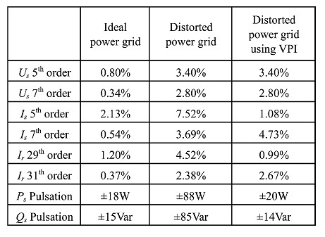

Table 7.2 Harmonic analysis data with the proposed dpc strategy

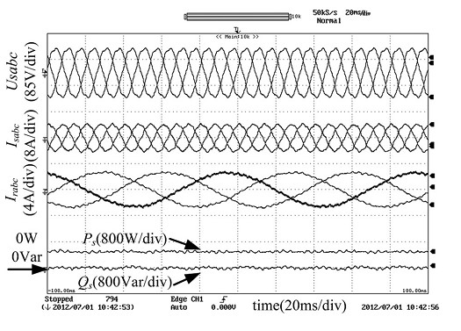

Fig.7.5 Experimental result of the DFIG system steady performance under the distorted grid voltage condition with VPI enabled.

Regulator which is close to the experiment result under the ideal power grid condition as shown in Fig. 12. Besides, the stator current fifth-order harmonic component has been significantly restrained from 7.52% to 1.08%, and the seventh-order component increases from 3.69% to 4.73%. Moreover, the stator current THD has been reduced from 8.37% to 4.80%. Similar conclusion can be made when considering the rotor current harmonic components as shown in Table II. Fig. 15 shows the experiment result of the DFIG system transient performance at the moment of enabling the VPI regulator under the distorted grid voltage condition. It can be seen that, before the enabling moment, severe stator active and reactive power pulsations of±88 W and±85 Var, as well as severely distorted stator currents can be observed. Nevertheless, when the VPI regulator is enabled, the stator active and reactive power pulsation can be successfully restrained within about 40 ms to ±20 W and±14 Var, respectively, and no impulse or instability response appears. A stepping of stator active power reference from 300 to 500 W is used to test the DFIG system transient response under the distorted grid voltage condition with the VPI regulator, as illustrated in Fig. 16. Before the stepping moment, the actual value of stator active power follows precisely to the reference signal, and there is almost no control error in the stator active power.

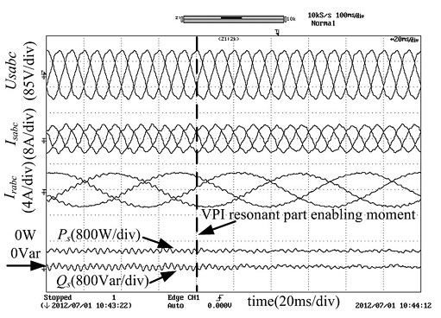

Fig.7.6 Experimental result of the DFIG system transient performance under the distorted grid voltage condition with VPI enabled.

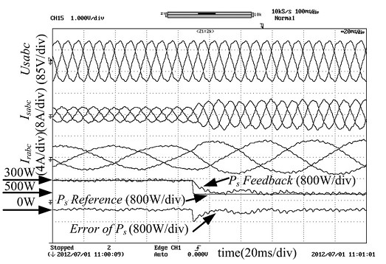

Fig.7.7 Experimental result of the DFIG stator active power reference stepping transient performance under the distorted grid voltage condition with VPI enabled.

When stator active power stepping happens and large control error emerges, the PI part of VPI can successfully minimize the control error and finally regulate the stator active power following the reference signal. During the transient process, the VPI regulator maintains effectiveness in regulating the 300 Hz ac signal, which verifies the independent working capability of PI part and the VPI regulator. Therefore, based on the experiment results shown in Figs. 15 and 16, the fast dynamic response advantage of the proposed DPC strategy in terms of both dc and 300 Hz ac signals tracking has been validated. Fig. 17 shows the experimental result of the DFIG operation from the sub synchronous state to super-synchronous state with the VPI regulator under the distorted grid condition. During the process of rotor accelerating from 800 (0.8 p.u.) to 1200 rpm (1.2 p.u.), the proposed DPC strategy using the VPI regulator can achieve smooth rotor current changing, and the stator output active power remains constant during the whole process, the stator power control error also remains zero. This result verifies that DFIG using the DPC strategy with the VPI regulator can operate normally under both sub synchronous and super synchronous state.

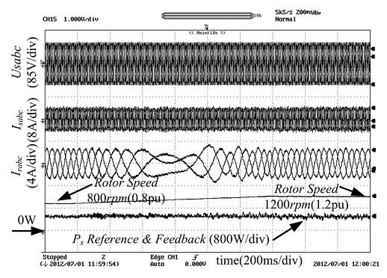

Fig.7.8 Experimental result of the DFIG system operating from sub-synchronous to super-synchronous state under the distorted grid voltage condition with VPI enabled.

Fig . result of the DFIG system performance under the distorted grid voltage condition with VPI disabled.

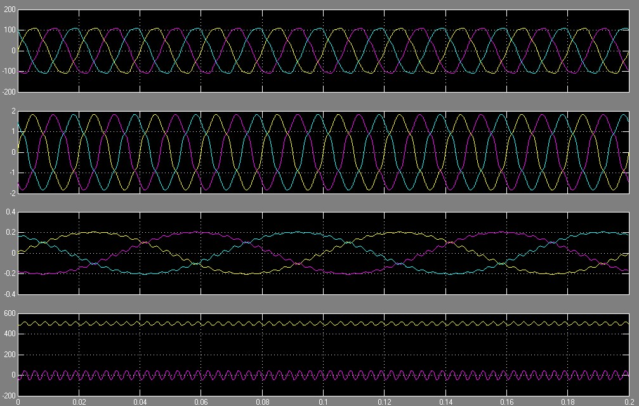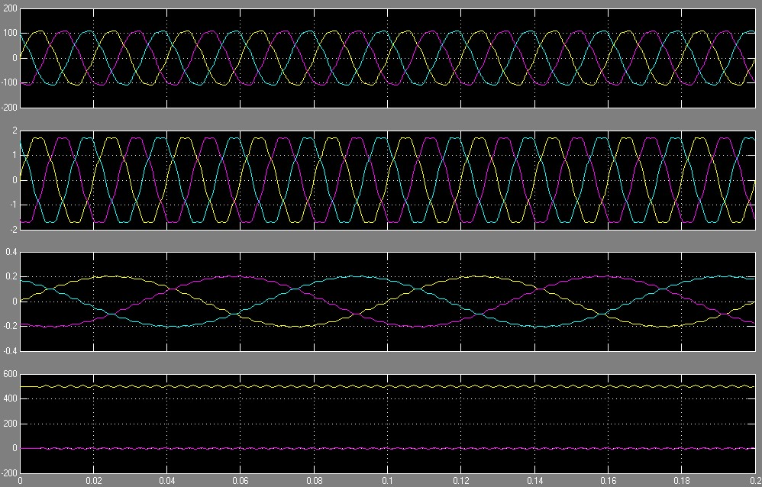

Fig. result of the DFIG system steady performance under the distorted grid voltage condition with VPI enabled.

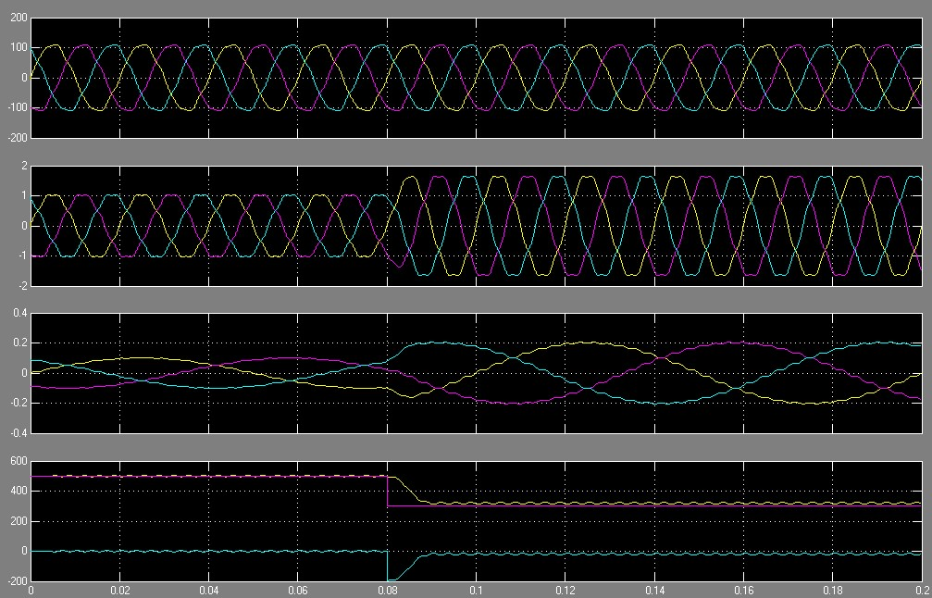

Fig. result of the DFIG stator active power reference stepping transient performance under the distorted grid voltage condition with VPI

Enabled

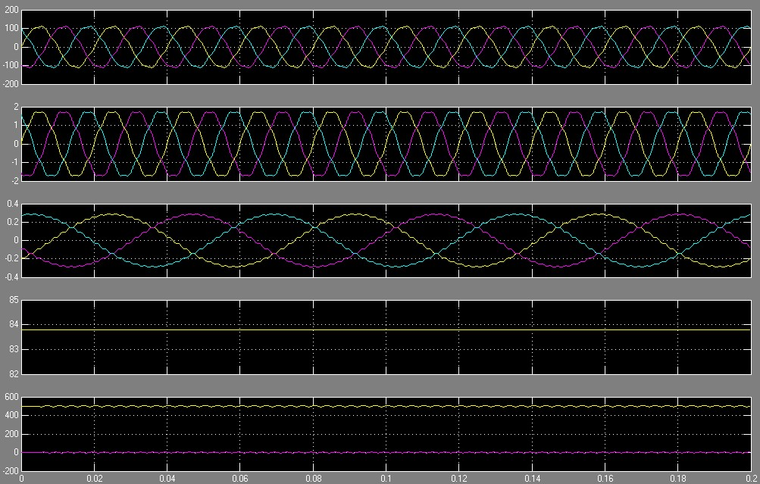

Fig. Experimental result of the DFIG system transient performance under the distorted grid voltage condition with VPI enabled.

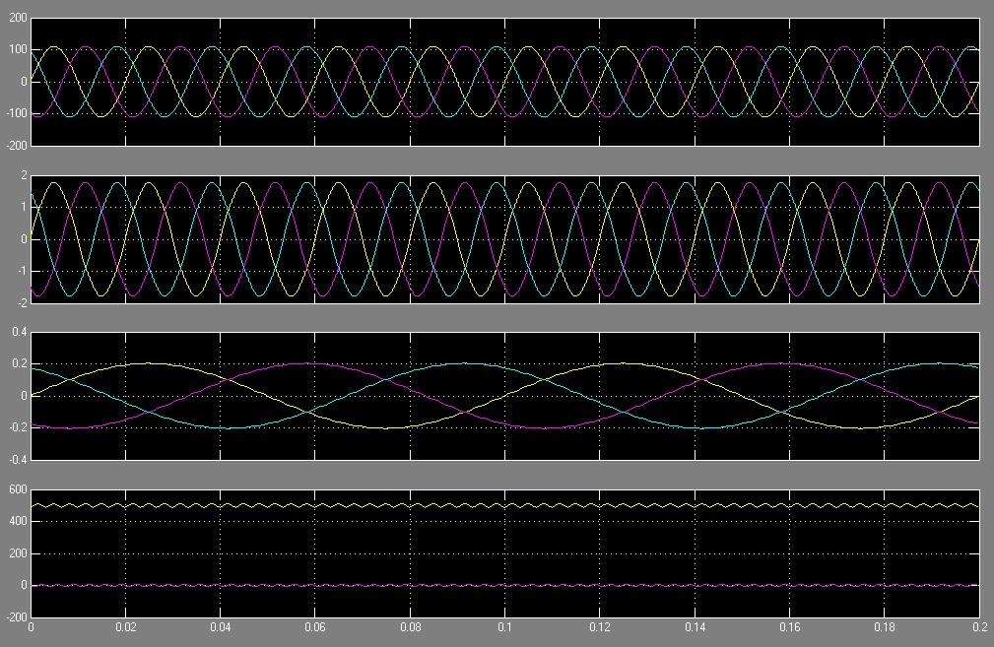

Fig. Experimental result of the DFIG system performance under the ideal grid voltage condition.

## 7.3 CONCLUSION

The project has presented a VPI-based Direct Power Control strategy for a wind turbine driven DFIG system under the harmonically distorted grid voltage. By applying the VPI regulator to suppress the power pulsation component, the proposed DPC strategy can successfully implement the smooth active and reactive power output of DFIG under the harmonic voltage. The steady power tracking precision and fast dynamic performance of the proposed DPC strategy are theoretically analyzed and proved experimentally. The proposed DPC strategy also shows an excellent disturbance rejection ability and closedloop operation stability. Experiment results have been carried out to validate the excellent dynamic and steady operation performance of the proposed DPC strategy.

## 8.REFERENCES

1. S. Muller, M. Deicke, and R. W. De Doncker, “Doubly fed induction generator systems for wind turbines,”IEEE Ind. Appl. Mag., vol. 8, no. 3, pp. 26–33, May/Jun. 2002.
2. G. Iwanski and W. Koczara, “DFIG-based power generation system with UPS function for variable-speed applications,”IEEE Trans. Ind. Electron., vol. 55, no. 8, pp. 3047–3054, Aug. 2008.
3. M. Mohseni, S. M. Islam, and M. A. Masoum, “Enhanced hysteresisbased current regulators in vector control of DFIG wind turbines,”IEEE Trans. Power Electron., vol. 26, no. 1, pp. 223–234, Jan. 2011.
4. D. Zhi, L. Xu, and B. W. Williams, “Model-based predictive direct power control of doubly fed induction generators,”IEEE Trans. Power Electron., vol. 25, no. 2, pp. 341– 351, Feb. 2010.
5. L. Xu, D. Zhi, and B. W. Williams, “Predictive current control of doubly fed induction generators,” IEEE Trans. Ind. Electron., vol. 56, no. 10, pp. 4143–4153, Oct. 2009.
6. A. Luna, F. K. Lima, D. Santos, and P. Rodriguez, “Simplified modeling of a DFIG for transient studies in wind power applications,”IEEE Trans. Ind. Electron., vol. 58, no.

1, pp. 9–20, Jan. 2011.

1. L. Xu, “Coordinated control of DFIG‟s rotor and grid side converters during network unbalance,”IEEE Trans. Power Electron., vol. 23, no. 3, pp. 1041–1049, May 2008. [8] J. Hu and Y. He, “Reinforced control and operation of DFIG-based windpowergeneration system under unbalanced grid voltage conditions,” IEEE Trans. Energy Convers., vol. 24, no. 4, pp. 905–915, Dec. 2009.
2. J. Hu, Y. He, L. Xu, and B. W. Williams, “Improved control of DFIG systems during network unbalance using PI–R current regulators,”IEEE Trans. Ind. Electron., vol. 56, no. 2, pp. 439–451, Feb. 2009.
3. P. Zhou, Y. He, and D. Sun, “Improved direct power control of a DFIGbased wind turbine during network unbalance,”IEEE Trans. Power Electron., vol. 24, no. 11, pp.

2465–2474, Nov. 2009.

1. H. Nian, Y. Song, P. Zhou, and Y. He, “Improved direct power control of a wind turbine driven doubly fed induction generator during transient grid voltage unbalance,”IEEE Trans. Energy Convers., vol. 26, no. 3, pp. 976–986, Sep. 2011.
2. G. K. Singh, “Power system harmonics research: A survey,”Euro. Trans Electr. Power, vol. 19, no. 2, pp. 151–172, Aug. 2007.
3. J. Hu, H. Nian, H. Xu, and Y. He, “Dynamic modeling and improved control of

DFIG under distorted grid voltage conditions,”IEEE Trans. Energy Convers., vol. 26, no. 1, pp. 163–175, Mar. 2011.

1. H. Xu, J. Hu, and Y. He, “Operation of wind-turbine-driven DFIG systems under distorted grid voltage conditions: Analysis and experimental validations,”IEEE Trans.

Power Electron., vol. 27, no. 5, pp. 2354–2366, May 2012.

1. V. Phan and H. Lee, “Control strategy for harmonic elimination in standalone DFIG applications with nonlinear loads,”IEEE Trans. Power Electron., vol. 26, no. 9, pp. 2662– 2675, Sep. 2011.
2. G. Iwanski and W. Koczara, “Standalone double-fed induction generator,” in The Industrial Electronics Handbook, Power Electronics and Motor Drives. Boca Raton, FL, USA: CRC Press, 2011, pp. 23-1–23-15.
3. C. Liu, F. Blaabjerg, W. Chen, and D. Xu, “Stator current harmonic control with resonant controller for doubly fed induction generator,”IEEE Trans. Power Electron., vol. 27, no. 7, pp. 3207–3220, Jul. 2012.
4. R. Datta and V. T. Ranganathan, “Direct power control of grid-connected wound rotor induction machine without rotor position sensors,”IEEE Trans. Power Electron., vol. 16, no. 3, pp. 390–399, May 2001.
5. L. Xu and P. Cartwright, “Direct active and reactive power control of DFIG for wind energy generation,”IEEE Trans. Energy Convers., vol. 21, no. 3, pp. 750–758, Sep. 2006.
6. D. Zhi and L. Xu, “Direct power control of DFIG with constant switching frequency and improved transient performance,”IEEE Trans. Energy Convers., vol. 22, no. 1, pp. 110–118, Mar. 2007.
7. C. Lascu, L. Asiminoaei, I. Boldea, and F. Blaabjerg, “High performance current controller for selective harmonic compensation in active power filters,”IEEE Trans.

Power Electron., vol. 22, no. 5, pp. 1826–1835, Sep. 2007.

1. C. Lascu, L. Asiminoaei, I. Boldea, and F. Blaabjerg, “Frequency response analysis of current controllers for selective harmonic compensation in active power filters,”IEEE Trans. Ind. Electron., vol. 56, no. 2, pp. 337– 347, Feb. 2009.
2. D. N. Zmood, D. G. Holmes, and G. H. Bode, “Frequency-domain analysis of threephase linear current regulators,”IEEE Trans. Ind. Appl., vol. 37, no. 2, pp. 601–610, Mar./Apr. 2001.
3. D. N. Zmood and D. G. Holmes, “Stationary frame current regulation of PWM inverters with zero steady-state error,”IEEE Trans. Power Electron., vol. 18, no. 3, pp. 814–822, May 2003.
4. G. Shen, X. Zhu, J. Zhang, and D. Xu, “A new feedback method for PR current control of LCL-filter-based grid-connected inverter,”IEEE Trans. Ind. Electron., vol. 57, no. 6, pp. 2033–2041, Jun. 2010.
5. C. Liu, D. Xu, N. Zhu, F. Blaabjerg, and M. Chen, “DC-voltage fluctuation elimination through a DC-capacitor current control for DFIG converters under unbalanced grid voltage conditions,”IEEE Trans. Power Electron., vol. 28, no. 7, pp. 3206–3218, Jul. 2013.
6. C. Liu, W. Chen, F. Blaabjerg, and D. Xu, “Optimized design of resonant controller for stator current harmonic compensation in DFIG wind turbine systems,” inProc. IEEE Appl. Power Electron. Conf. Expo., Feb. 2012, pp. 2038–2044.
7. R. Zeng, H. Nian, and P. Zhou, “A three-phase programmable voltage sag generator for low voltage ride-through capability test of wind turbine,” in Proc. IEEE Energy Convers. Cong. Expo., Atlanta, GA, USA, 2010, pp. 305–311.